**The British College**

**KATHMANDU**

**Coursework Submission Coversheet**(individual coursework only)

**Faculty of Arts, Environment and Technology LBU Student Id:**

C7261108

C7261108112008

**For checking by the student:**

Please ensure all information is complete and correct and attach this form securely to the front of your work before posting it in a coursework collection box.

Award name: Bsc Hons in Computing

Module code: 15781

Module name: Advance Database System (ADS)

Module run: 2022

Coursework title: Data warehouse Design and Development

Due Date: 01/18/2022

Module leader: (In LBU): Jackie Campbell, Sanela Lazarevski

Module tutor: (In TBC): Dibya Tara Shakya

**TURNITIN** Checked: YES NO ***(please circle)***

Submission date& time: Date: 01/18/2022 Time: After noon

**Total Word Count: 8369 Total Number of Pages (including this front sheet):51**

**In submitting this form with your assignment, you make the following declaration:**  
I declare, that the coursework submitted is my own work and has not (either in whole or part) been submitted towards the award of any other qualification either at LBU or elsewhere. I have fully attributed/referenced all sources of information used during the completion of my assignment, and I am aware that failure to do so constitutes an assessment offence.

Signed: Anmol Karki Date: 01/13/2023

**You are strongly advised to retain a second copy of your work in case of any query about the assignment.**

**For completion by the faculty:**

**This mark is provisional and subject to moderation and approval by the relevant examining board**

**Teacher's Feedback**

**Teacher's Signature: __________________________________ Date: _________________**

T

**Table of Contents**

1. Assignment 2 – Tasks 1 4
2. Task 1: Data Analysis/OLAP/Mining Investigation 4
3. Part A: Spread sheet Reports. 4
4. Benefits of Data Visualization Tools. 7
5. Data mining 7
6. On-line analytical processing 9
7. Advantages of OLAP 10
8. Charts and Reports: 10
9. MS-Excel Pivot Tables, Report and Charts 11
10. Part B: Data Analysis and Dashboards 15
11. Apex Dashboard Reports and Charts 17

The reports presented below were created with Oracle Apex and are based on the data that was provided to us for this work. The Leeds excel file was primarily used to create the charts shown below. 17

1. Tableau Reports and Charts 24
2. TASK 2 : Take your design and code further by using PL/SQL techniques ………………………………………….25
3. Appendix………………………………………………………………………………………………………………………………….47
4. Bibliography………………………………………………………………………………………………………………………………49

Assignment 2 – Tasks 1

## **Task 1: Data Analysis/OLAP/Mining Investigation**

### **Part A: Spread sheet Reports.**

**The process of cleansing**, converting, and modeling data in order to find relevant information for corporate decision-making is known as data analysis. Extracting usable information from data and making decisions based on that analysis are the goals of data analysis.

Every time we make a decision in daily life, as a simple example of data analysis, we consider what happened previously or what would happen if we make that specific choice. This is nothing more than evaluating the past or the future and making choices in light of it. For that, we assemble our past experiences or our future aspirations. So, all that is data analysis. Today, data analysis refers to the same process an analyst does for commercial goals.

Data processing and manipulation, connection and correlation analysis between data sets, pattern and trend identification, and interpretation are all made simpler for users by data analysis tools. Here is a comprehensive list of the equipment used in research to analyze data.

* [**MonkeyLearn**](https://monkeylearn.com/) | perform no-code text analysis
* [**RapidMiner**](https://monkeylearn.com/blog/data-analysis-tools/#rapidminer) | build predictive analysis models
* [**KNIME**](https://monkeylearn.com/blog/data-analysis-tools/#knime) | create data science workflows
* [**Talend**](https://monkeylearn.com/blog/data-analysis-tools/#talend) | collect your data in a single platform
* [**Excel**](https://monkeylearn.com/blog/data-analysis-tools/#excel) | use powerful data analysis formulas
* [**Airtable**](https://monkeylearn.com/blog/data-analysis-tools/#airtable) | part spreadsheet, part database
* [**Power BI**](https://monkeylearn.com/blog/data-analysis-tools/#power-bi) | see your results in real time
* [**Tableau**](https://monkeylearn.com/blog/data-analysis-tools/#tableau) | visualize your results in style
* [**ClicData**](https://monkeylearn.com/blog/data-analysis-tools/#clicdata) | connect data and create interactive dashboards (Wolff, 2020)

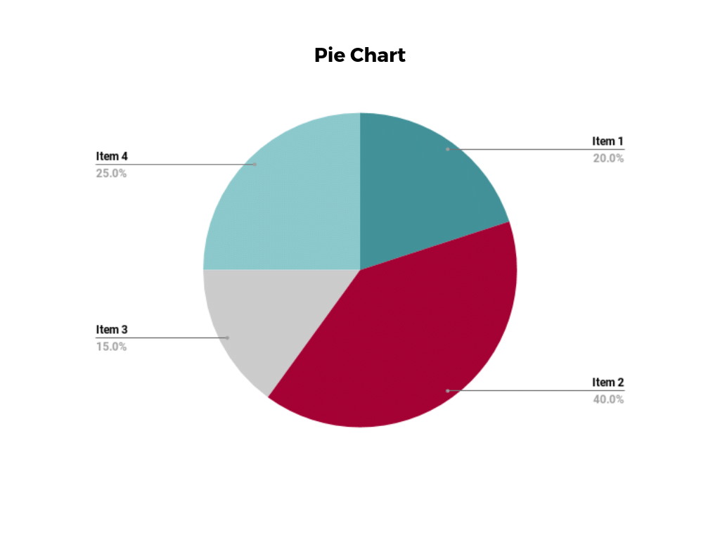

Figure:- The image below shows that how can data be visualized.

## **Benefits of Data Visualization Tools.**

* Better business decisions.
* **Faster and easier access to important business insights.**
* **Teams can communicate findings in more productive ways with data visualisation.**
* **Data visualization tools identify insights that may otherwise be missed in traditional reporting methods.**
* **Quick and easy identification of the latest industry trends.**
* **Boost revenue with predictive sales analysis.**

# Data mining

**Companies** employ data mining as a method to transform unstructured data into information that is valuable. Businesses may learn more about their consumers to create more successful marketing campaigns, boost sales, and cut expenses by employing software to seek for patterns in massive volumes of data. Effective data collection, warehousing, and computer processing are prerequisites for data mining.

Massive volumes of data are analyzed in the process of "mining" meaningful knowledge from them in order to assist enterprises in problem-solving, trend prediction, risk reduction, and opportunity discovery. Data mining is similar to actual mining in that both involve sifting through vast amounts of content in search of valuable resources and components.

In order to address problems and provide information that can be used to take action, data mining also involves establishing linkages and locating patterns, anomalies, and correlations.

**Advantages Of Data Mining**

Gaining as many benefits as you can is critical since our world is data-centric and we live and work in it. Data mining gives us the tools to solve concerns and problems. Benefits of data mining include:

* It aids businesses in obtaining accurate information.
* Compared to other data applications, it is a productive and affordable option.
* Businesses may adapt their operations and output in a lucrative way.
* Both modern and antiquated systems are used in data mining.
* It aids businesses in making wise selections.
* It aids in identifying fraud and credit concerns.
* It makes it simple for data scientists to swiftly evaluate massive volumes of data.
* The data may be used by data scientists to identify fraud, create risk models, and enhance product safety.
* It aids data scientists in starting rapidly.

# On-line analytical processing

On-line analytical processing is known as OLAP. Through quick, consistent, interactive access to a variety of views of data that have been transformed from raw data to reflect the true dimensionality of the enterprise as understood by the clients, analysts, managers, and executives can gain insight into information using OLAP, a category of software technology.

Business information is multidimensionally analyzed using OLAP, which also supports advanced data modeling, complicated estimates, and trend analysis. The vital framework for intelligent solutions, which includes business performance management, planning, budgeting, forecasting, financial documentation, analysis, simulation-models, knowledge discovery, and data warehouse reporting, is being quickly improved. End-clients may execute ad hoc analysis of records in many dimensions thanks to OLAP, giving them the knowledge and expertise, they need for enhanced decision making.

## **Advantages of OLAP**

* 1. An OLAP cube contains consistent data and calculations.
  2. OLAP databases may be quickly searched for general or detailed keywords.
  3. Business modeling, data mining, and performance reporting tools may all be built on top of OLAP.
  4. Enables users to slice and dice data cubes using a variety of dimensions, metrics, and filters.
  5. It works well for time series analysis.
  6. Using OLAP, finding certain clusters and outliers is simple.
  7. It is a potent online analytical process system with great visualization that offers quicker reaction times.

## **Charts and Reports:**

The document contains the graphs and summaries required for the next component. Oracle Apex, Tableau, and MS-Excel were the three different technologies used to construct the reports. In addition to being used to correctly view and analyze data, these technologies have also been used to create a number of drill-down reports that provide an even more in-depth analysis of the data trend.

# MS-Excel Pivot Tables, Report and Charts

The reports shown below were created using MS-Excel based on the information given to us to do this work. The necessary pivoting was done once the tables were downloaded, loaded, and put into the program.

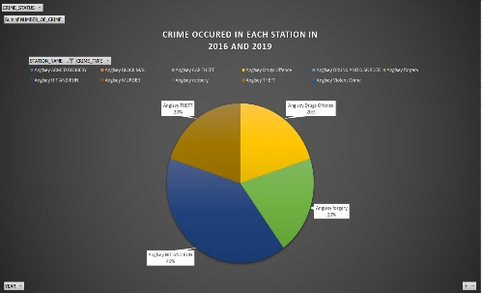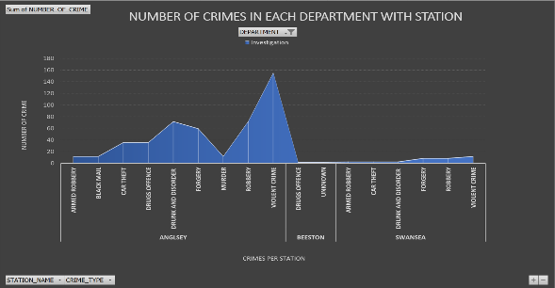***DASHBOARD***

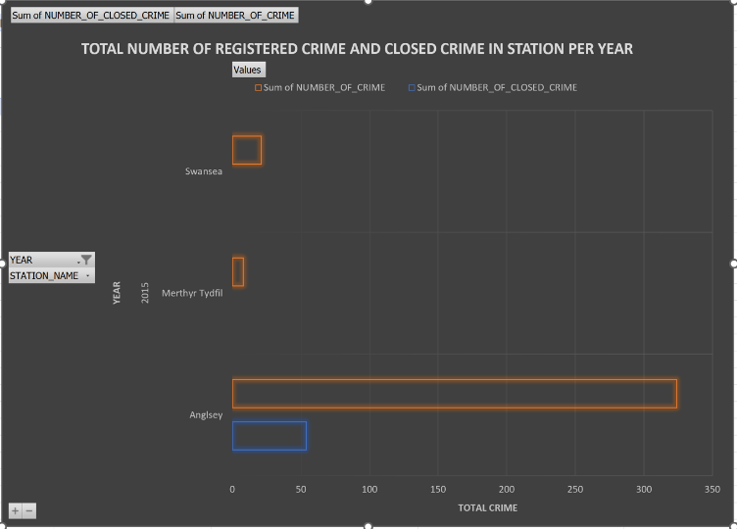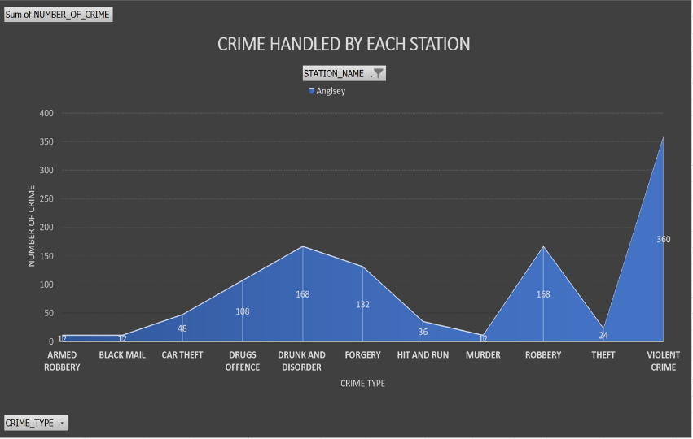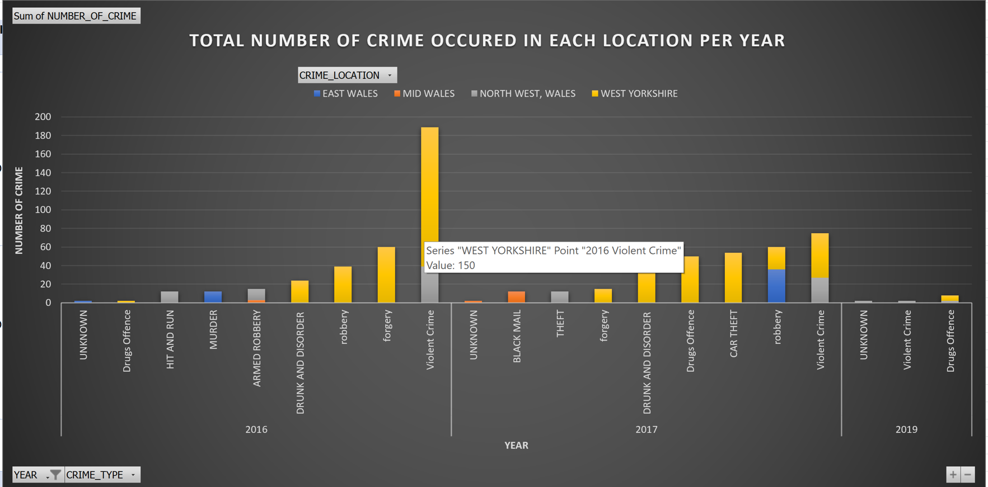

***Report1: Total number of crime occurred in each location per year***

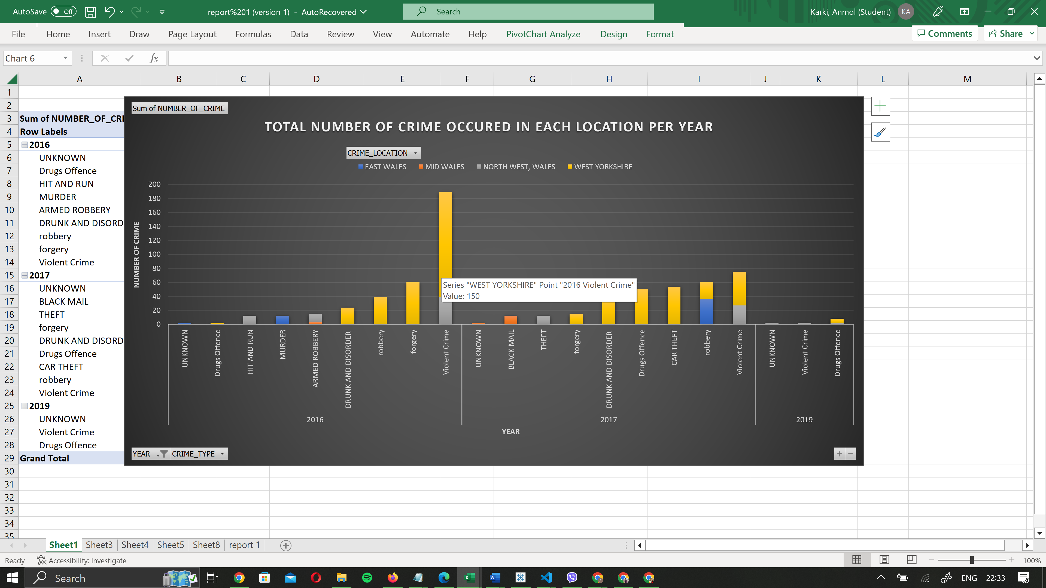

**DESCRIPTION**

The column chart given shows that the total number of crime which is been occurred in each location per year with its crime type.

We have total number of crimes in y axis whereas x axis shows year and crime type which was been held. The data is displayed for number of crime held in the given location which is stacked up and the total number of crime occurred are shown y axis. The crime types are grouped in year are shown yearly total number of crimes occurred in each location.

***Report2: Crime occurred in each station in 2016 and 2019 in percentage***

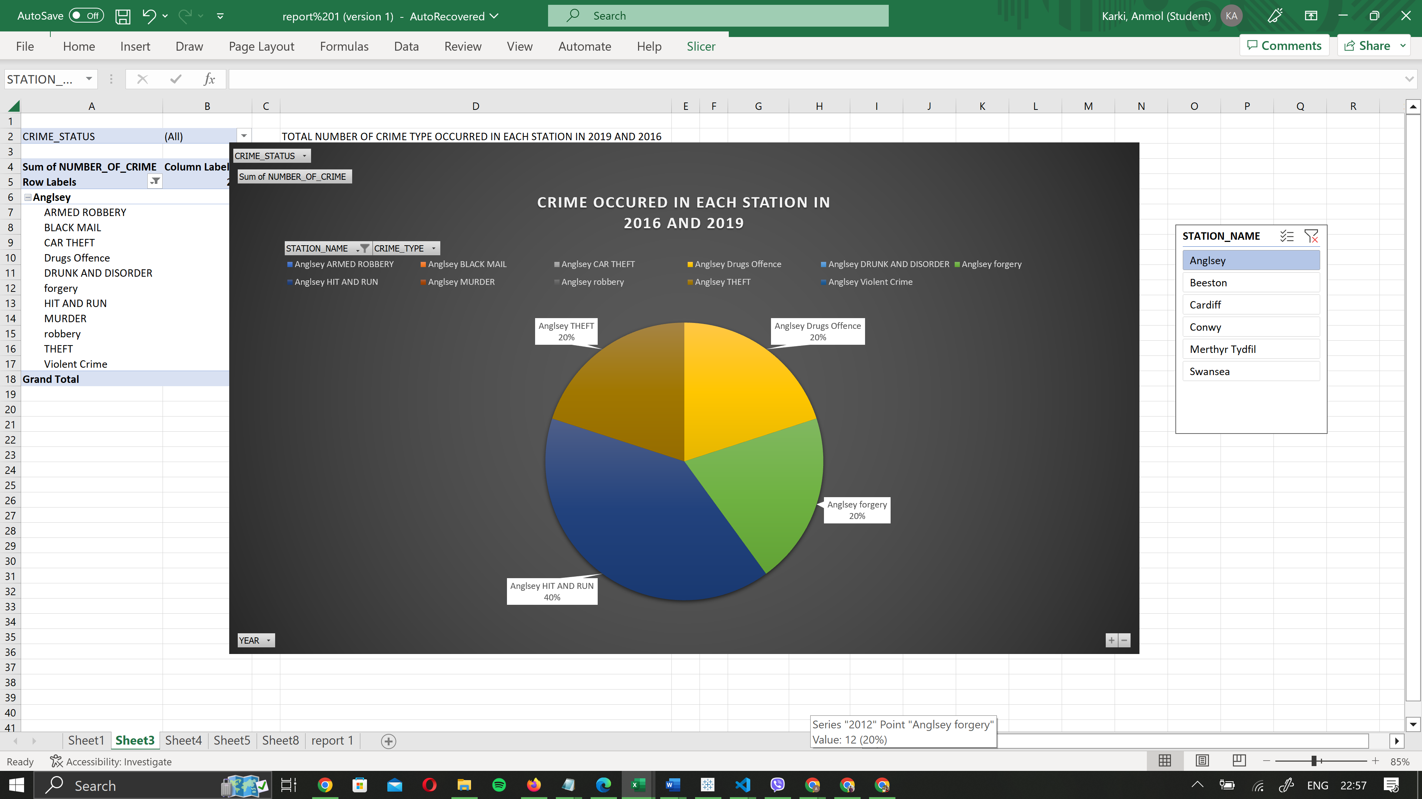

**DESCRIPTION**

The above pie chart shows that there are different crime types with different color and The tool tip in pie chart shows the station name along with crime type at second position of string . The percentage is also shown in the chart representing crime types occurring rate in that station. There is also a slicer used to calculate each or multiple station data.

***Report:- 3 Number of crimes registered in each station and handled by each department***

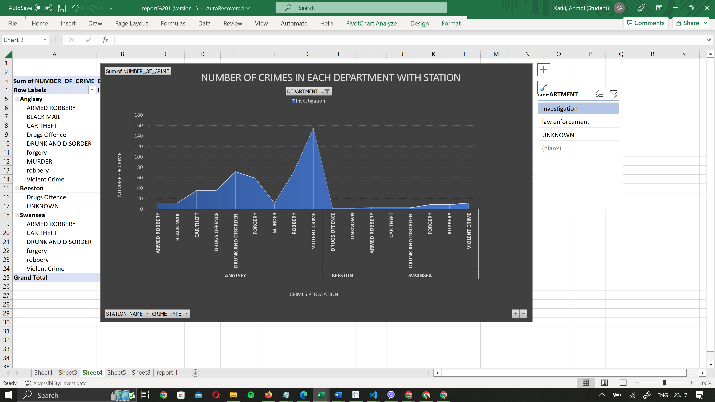

**DESCRIPTION**

The chart above shows that the total number of crime in y axis where as x axis shows the crimes occurred per station. The number of crime occurred in each crime type with respective station. Slicer has been used to separated each department data in order. The main purpose of this chart is to show number of crime according to crime type occurred in each station and been handled by department respectively.

***Report 4 Number of crime according to crime type handled by each station***

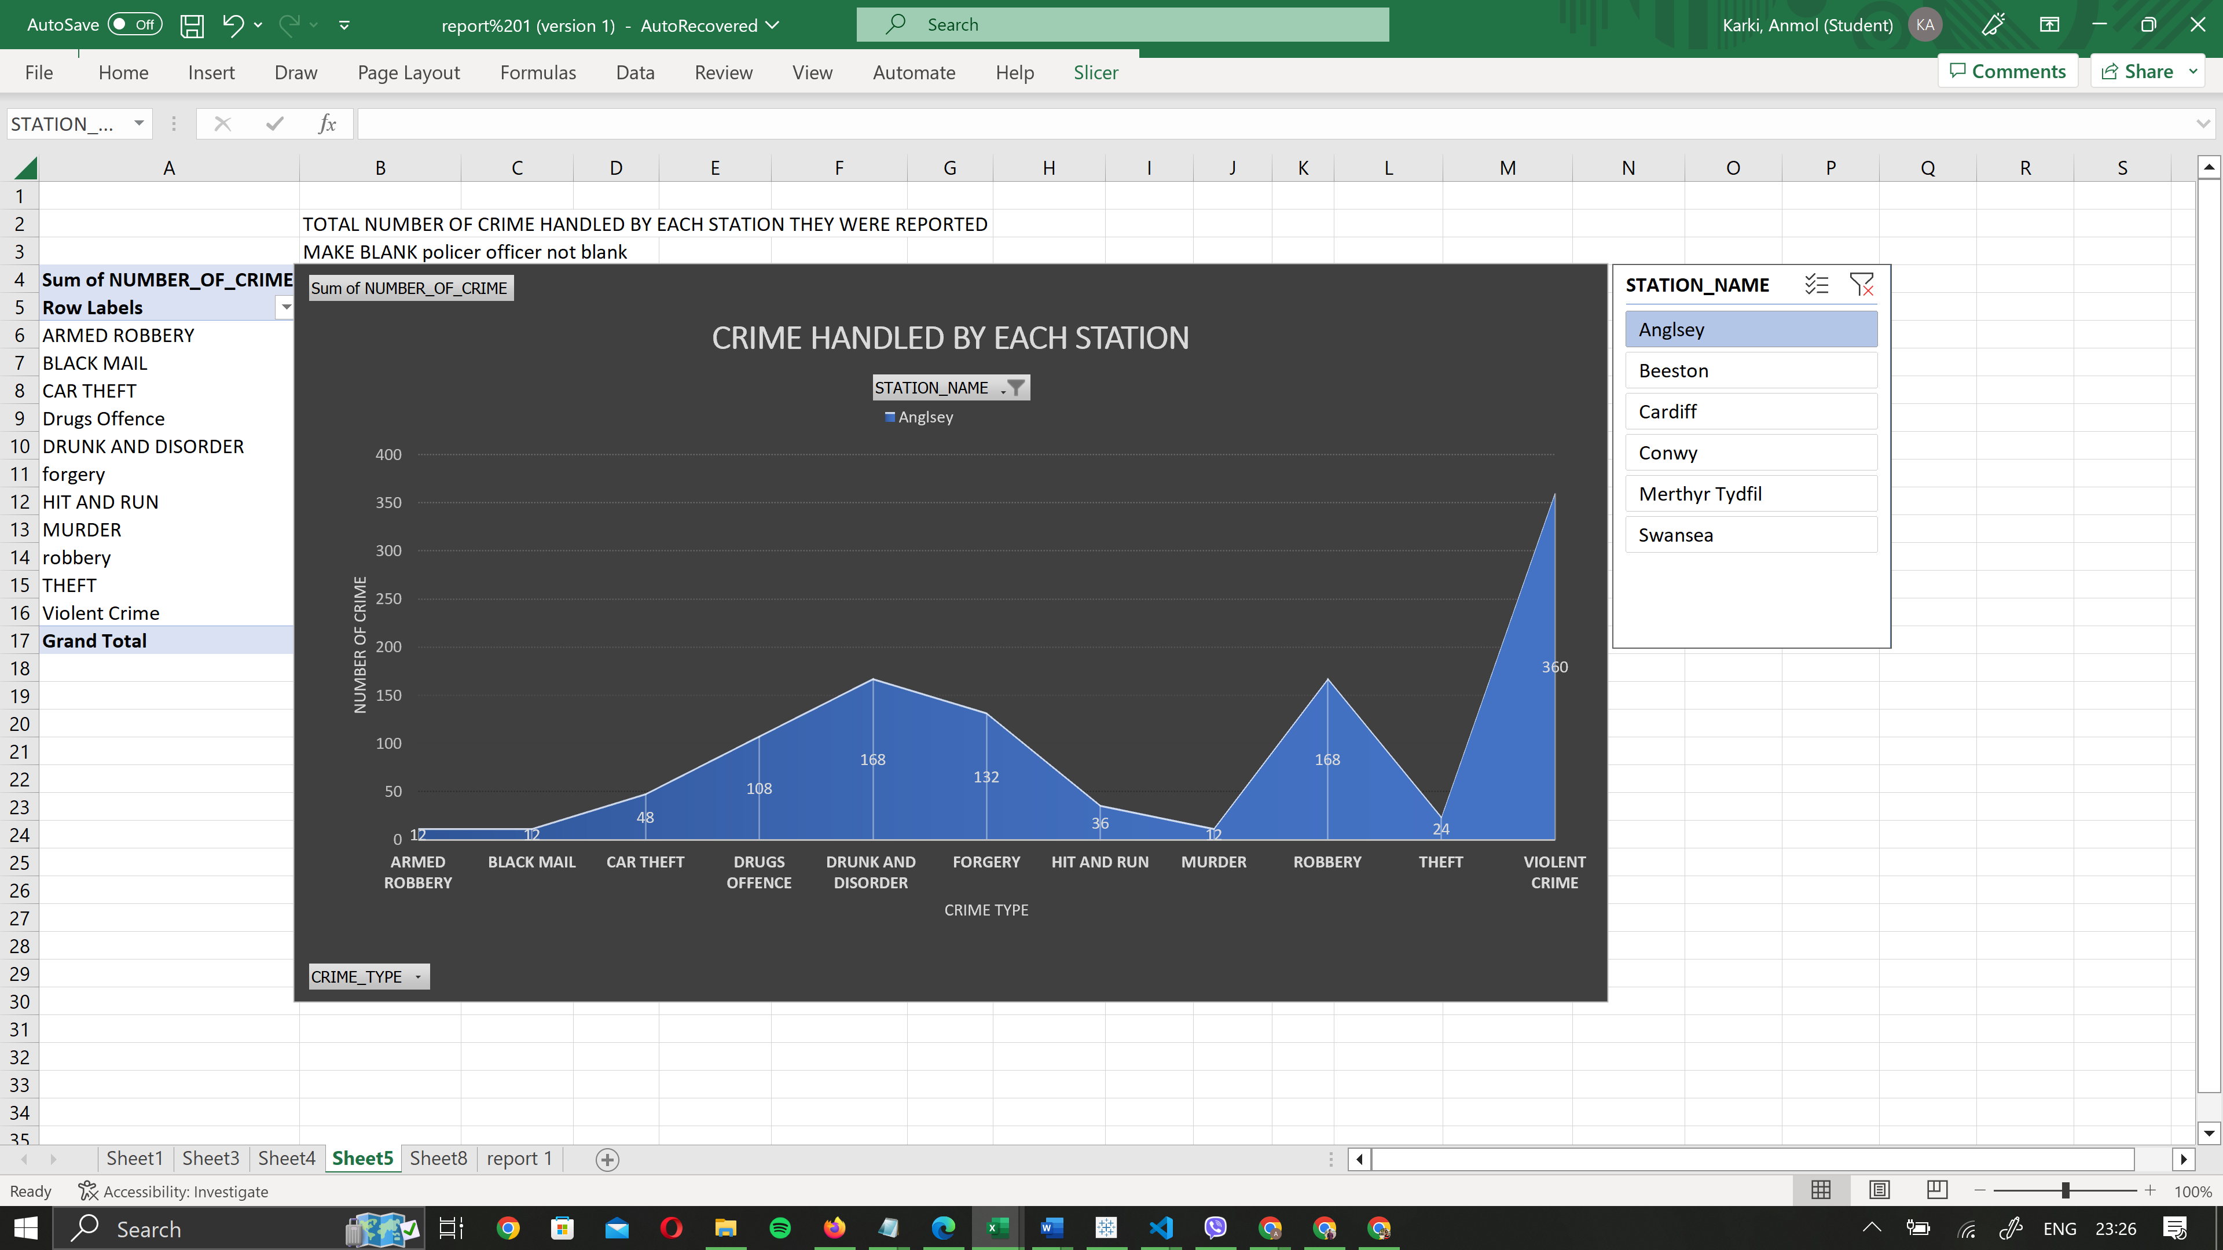

**DESCRIPTION**

The above chart shows number of crime in y axis where as crime type in x axis. The figure shows that number of crime according to crime type . Slicer to see data according to each station.

***Report 5:- Total number of registered and closed crime in station per year***

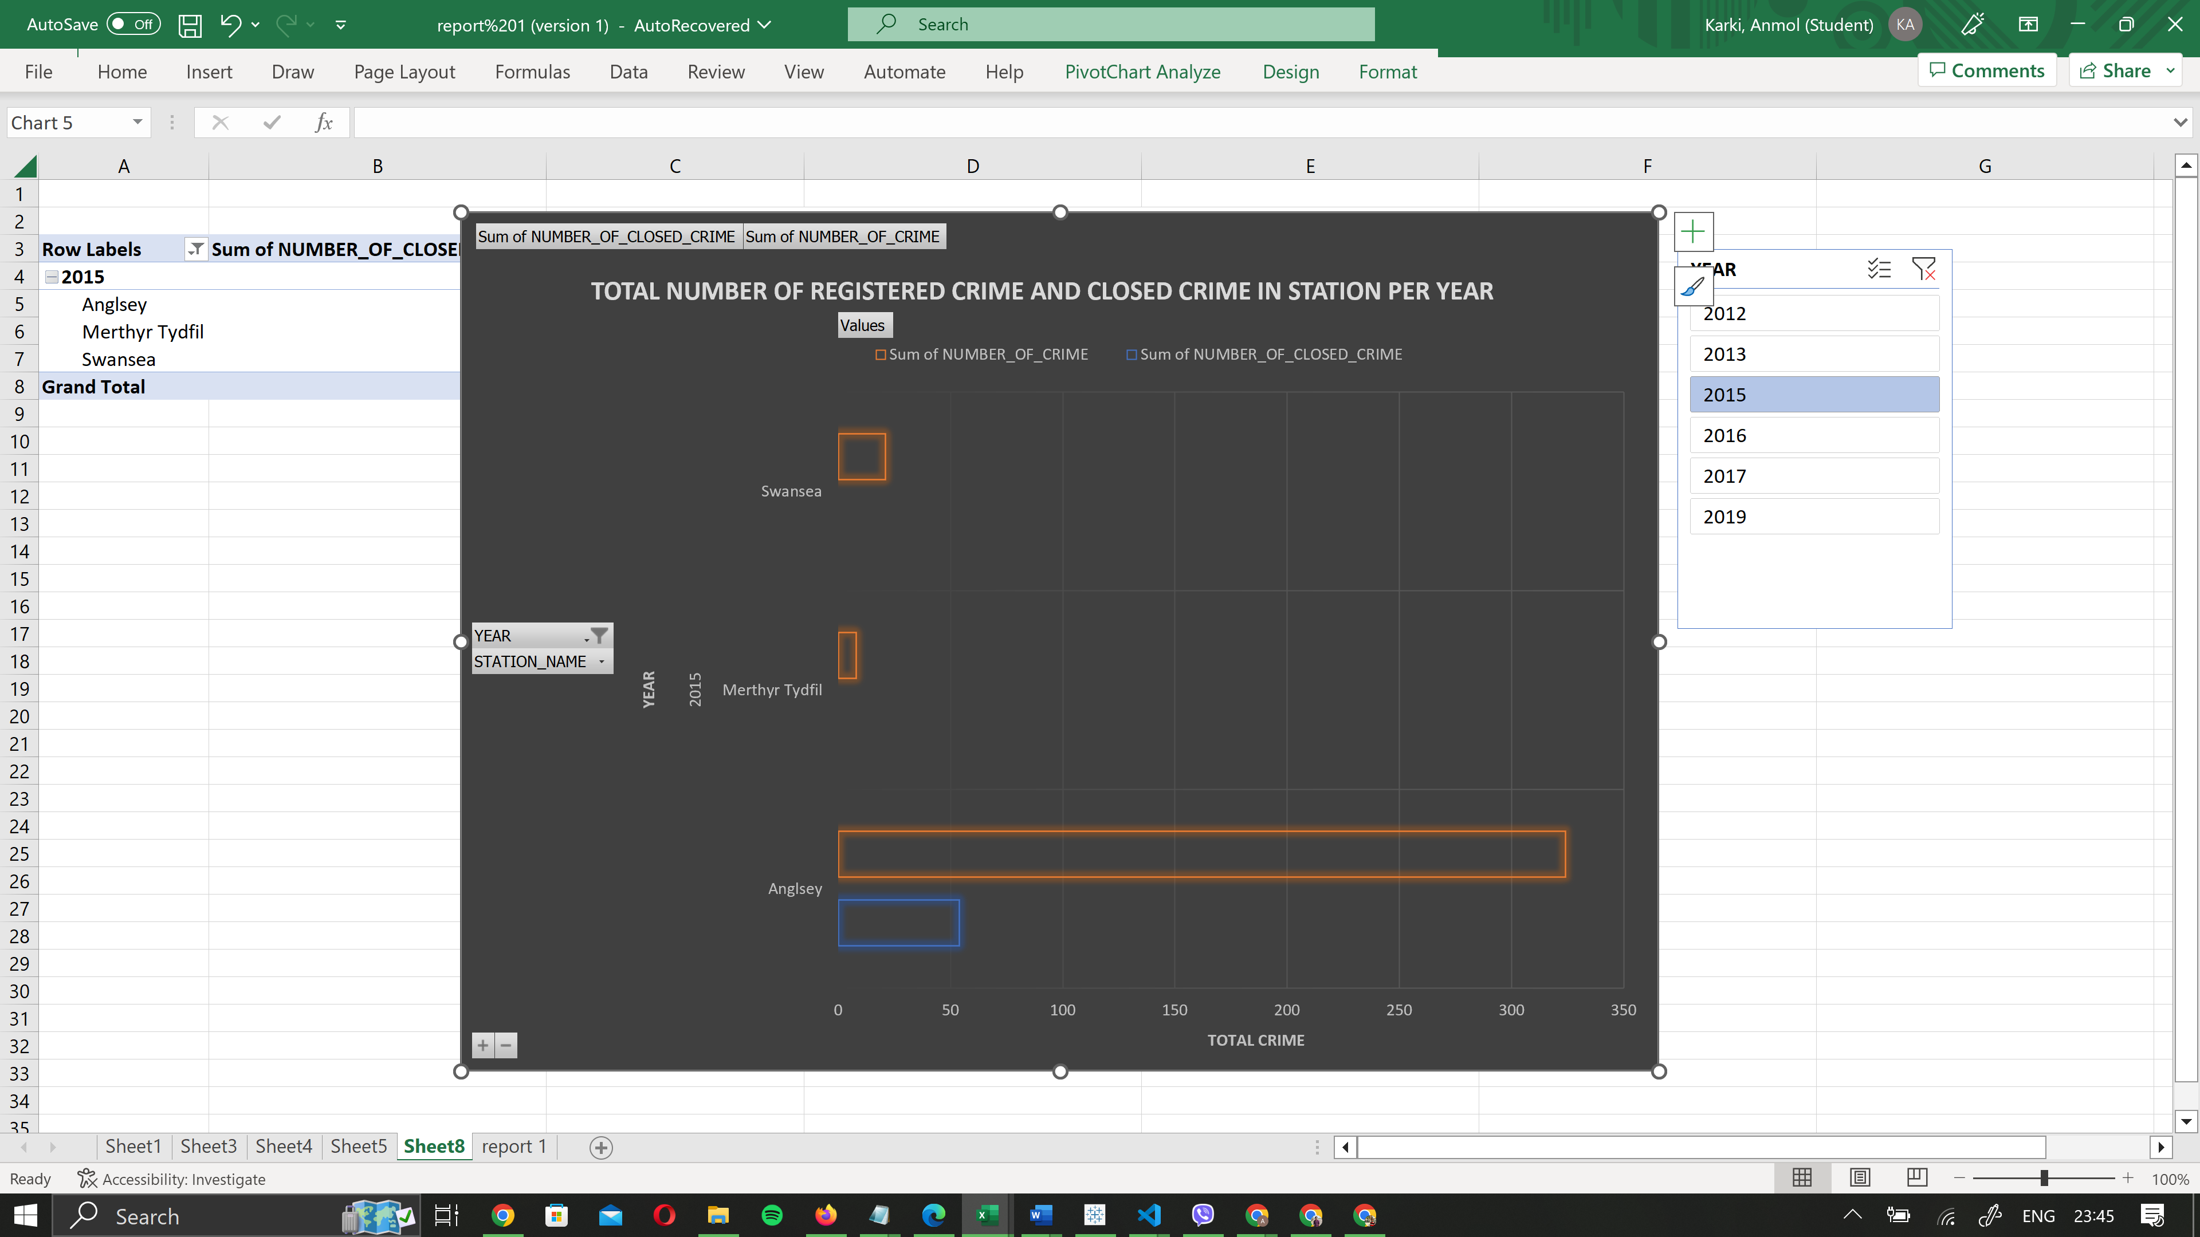

**DESCRIPTION**

The above chart shows year in y axis where as total number of crime x axis. The figure above signifies that crime solved and crime registered per station. The slice is being used to filter data according to dates.

# Part B: Data Analysis and Dashboards

***Data analysis***

Data analytics is the process of converting unstructured or raw data into a usable format. The converted data, after being cleansed, analyzed, and modeled, aids in decision-making, generating conclusions, and implementing predictive analytical processes. It is significant for organizations because it aids in the optimization of their performance by lowering costs through the use of more efficient methods of carrying out business choices in the presence of vast amounts of data. The basic idea behind data analytics is to make sense of the existing data, analyze it, and share improved business possibilities for the future. The benefits of data analytics will be provided to an organization.

• Identifying new opportunities and gaining new insights to assist them better manage their business.

• Providing useful information to help businesses make better decisions.

• Enabling businesses to make faster decisions, so saving time and energy.

• Improving tactics by focusing on the client and increasing company earnings.

The benefits provided by data analytics are similar to those provided by business intelligence; yet, they are used to generate different results. The primary purpose of data analytics is to model, cleanse, predict and transform the data as per the business needs. On the other hand, the primary purpose of business intelligence is to aid organizations to grow their businesses by providing support in decision making. (FRANKENFIELD, 2021)

***Dashboard***

A dashboard visualizes real-time data by aggregating and extracting meaningful information from all acquired data. A dashboard highlights all of the critical information that has a direct impact on a company's success (iDashboards, 2019). • Assisting in managing the complexity of running an organization by offering a comprehensive view of the main elements that affect the organization.

• Bringing together vital information from various departments and divisions within the organization • Providing immediate and easy access to critical information

• Displaying critical metrics and performance indicators in real time and assisting in making informed decisions

• Making it simple to browse throughout the program.

Dashboards are a wonderful way to monitor your business, to look for answers, and to see all of your most-important metrics at a glance. The visualizations on a dashboard may come from one underlying dataset or many, and from one underlying report or many. A dashboard can combine on-premises and cloud data, providing a consolidated view regardless of where the data lives. (Microsoft, 2021)

### **Apex Dashboard Reports and Charts**

# The reports presented below were created with Oracle Apex and are based on the data that was provided to us for this work. The Leeds excel file was primarily used to create the charts shown below.

***DASHBOARD***

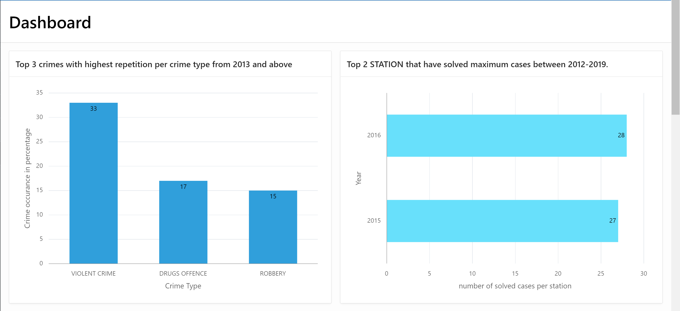

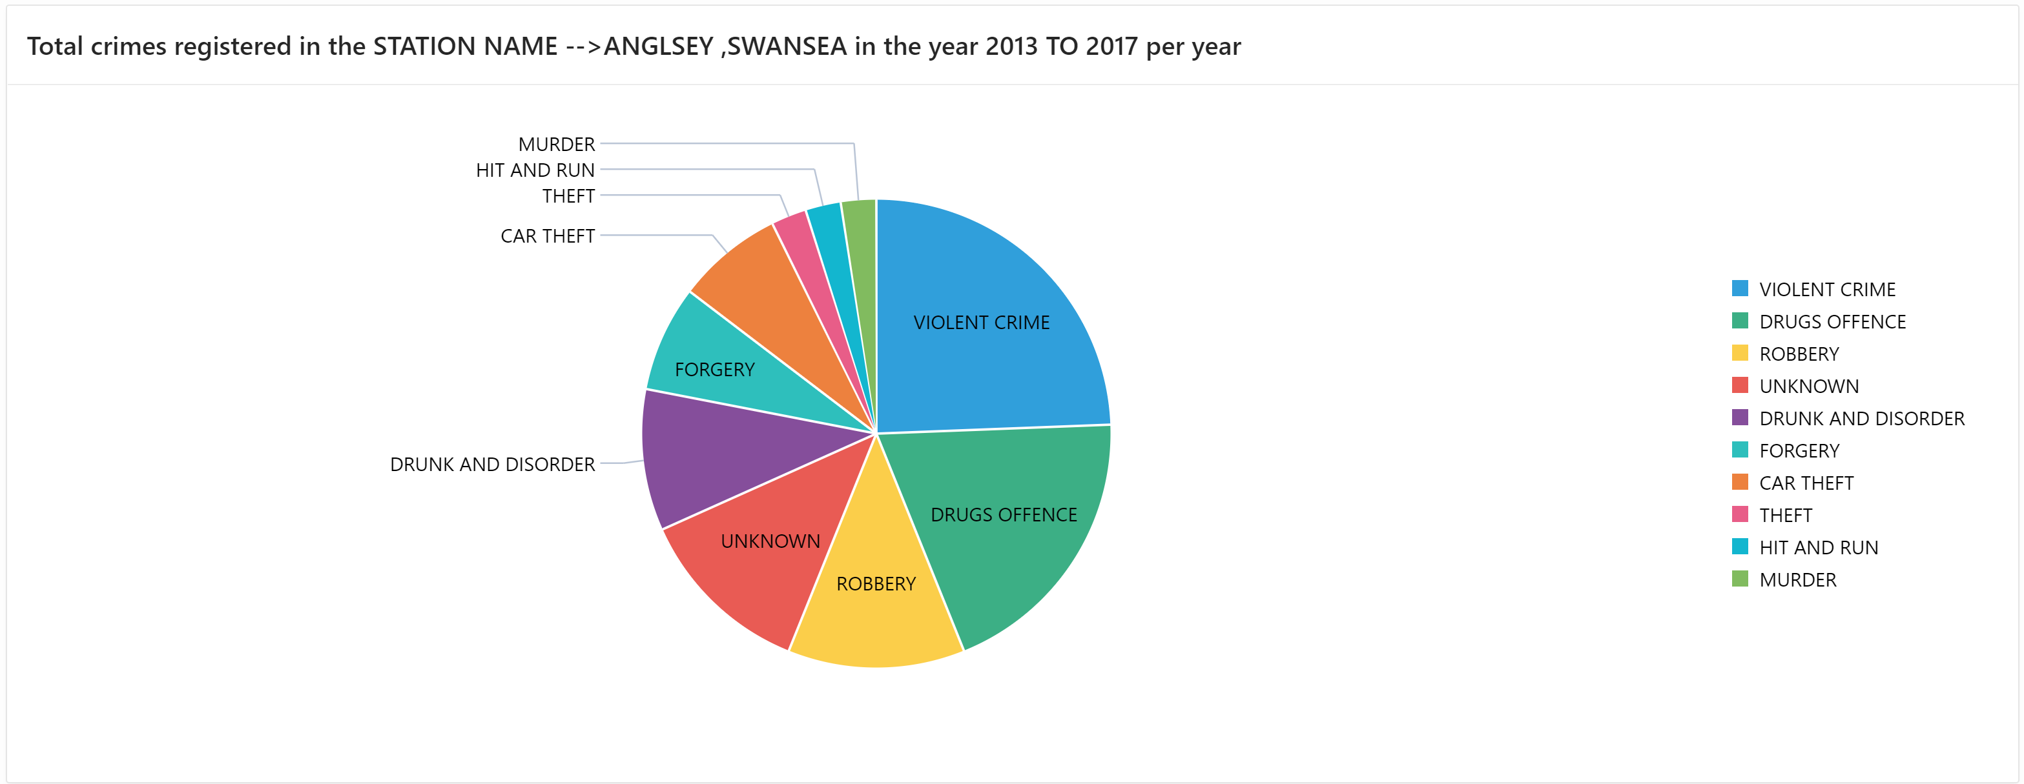

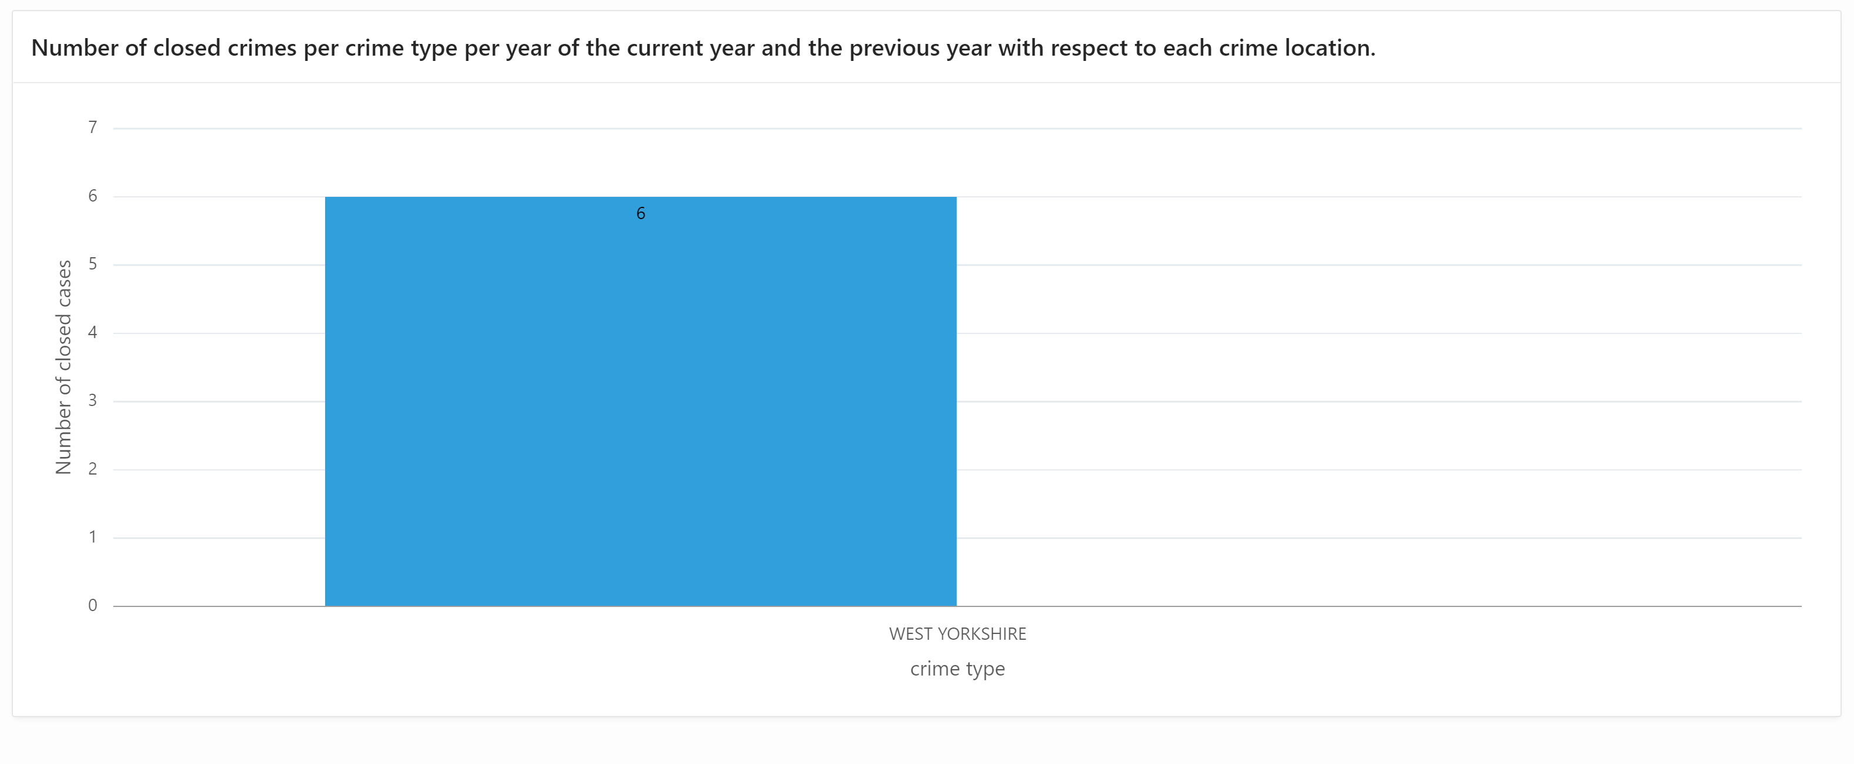

***Report1: Top 3 crimes with highest repetition per crime type from 2013 and above***

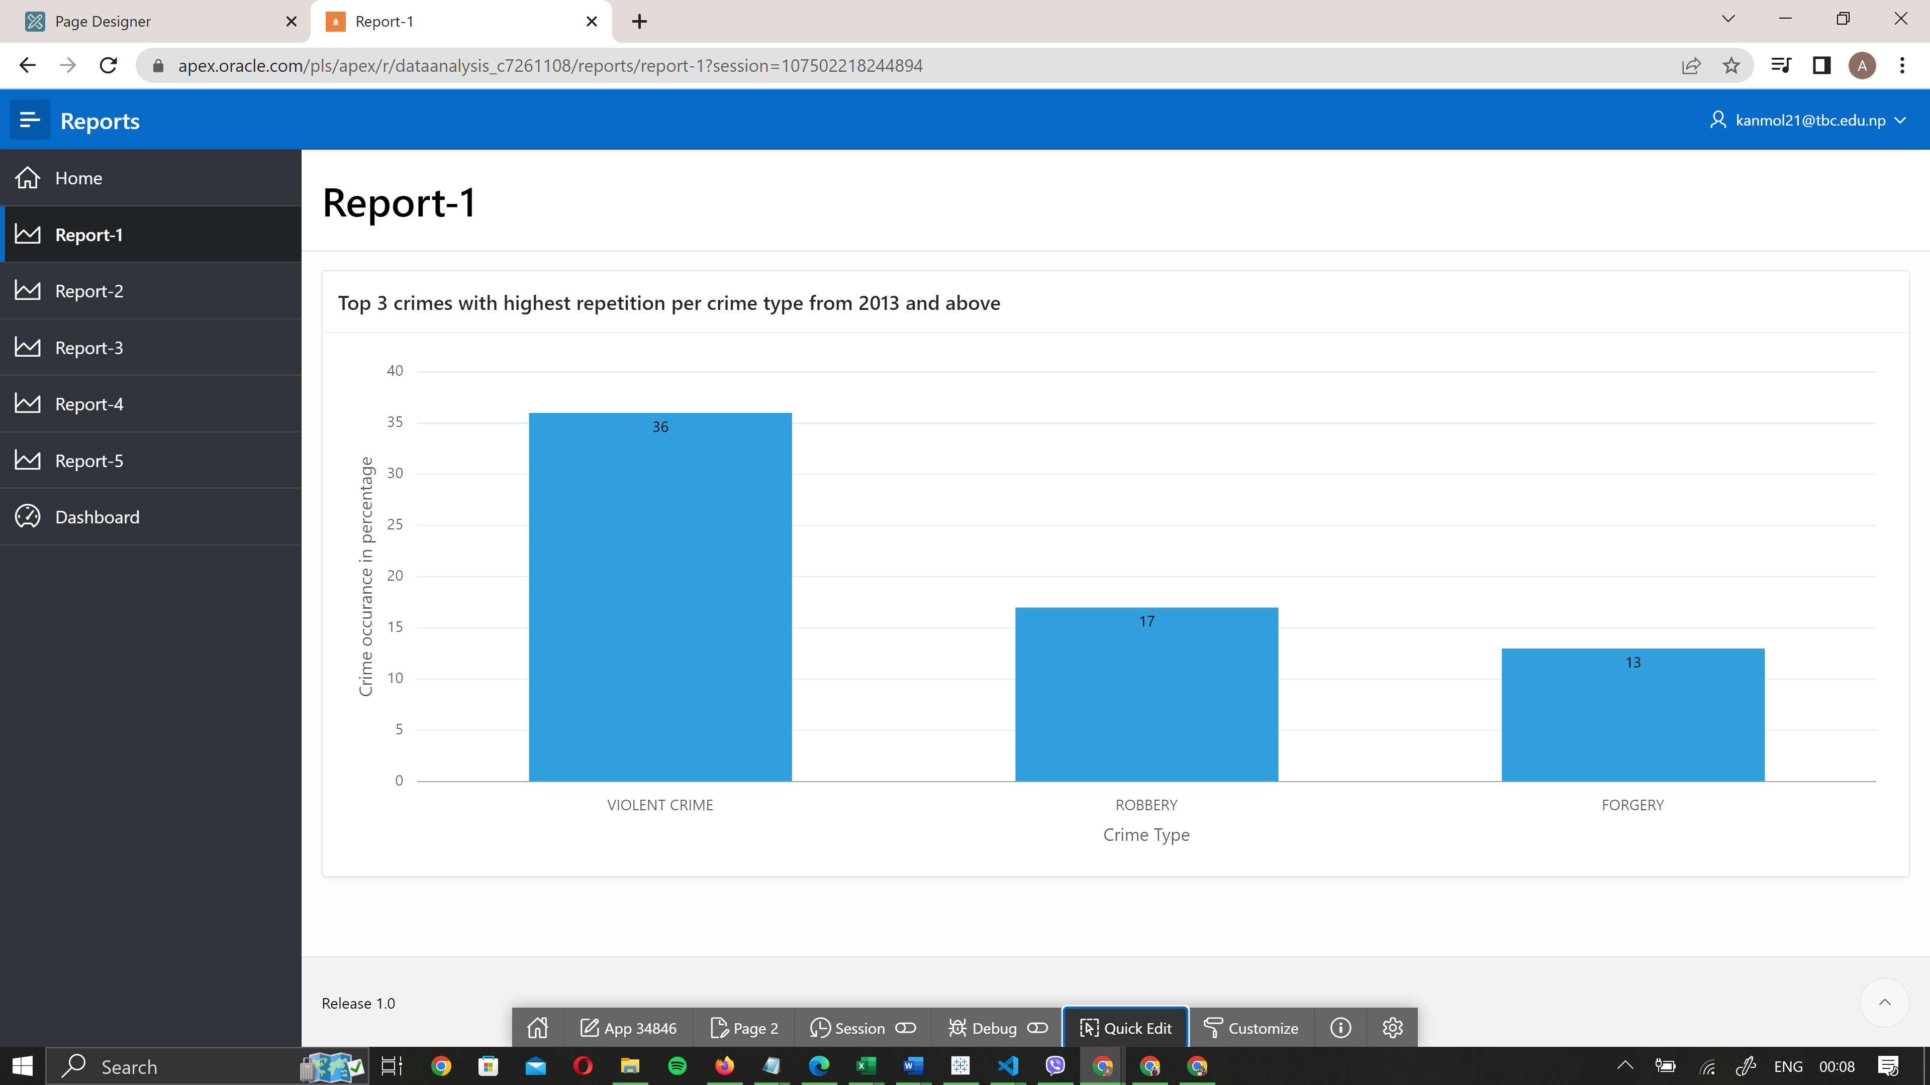

**DESCRIPTION**

The above chart shows that top 3 crimes which has highest occurrences rate from 2013 to till now. The number in y axis is crime occurrences percentage which is been calculated by total crime per crime type divided by total crime occurred till now multiplied by 100. The data in y axis is crime type. And the number inside bar is the occurrences rate.

***Report 2: Top 2 STATION that have solved maximum cases between 2012-2019.***

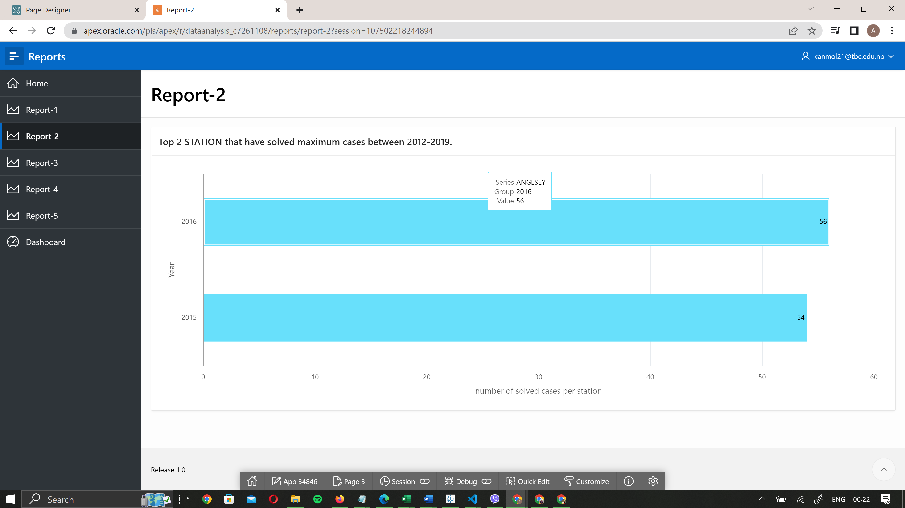

**DESCRIPTION**

The above chart shows that top 2 station which has tendency to solve maximum crime. The data in y axis is year and x axis is number of solved cases per station. When we hover bar it shows number of solved cases, station name and year. The data is shown between year of 2012 -2019

***REPORT 3: Total crimes registered in the STATION NAME🡪 ANGLSEY,SWANSEA in year 2013 to 2017 per year***

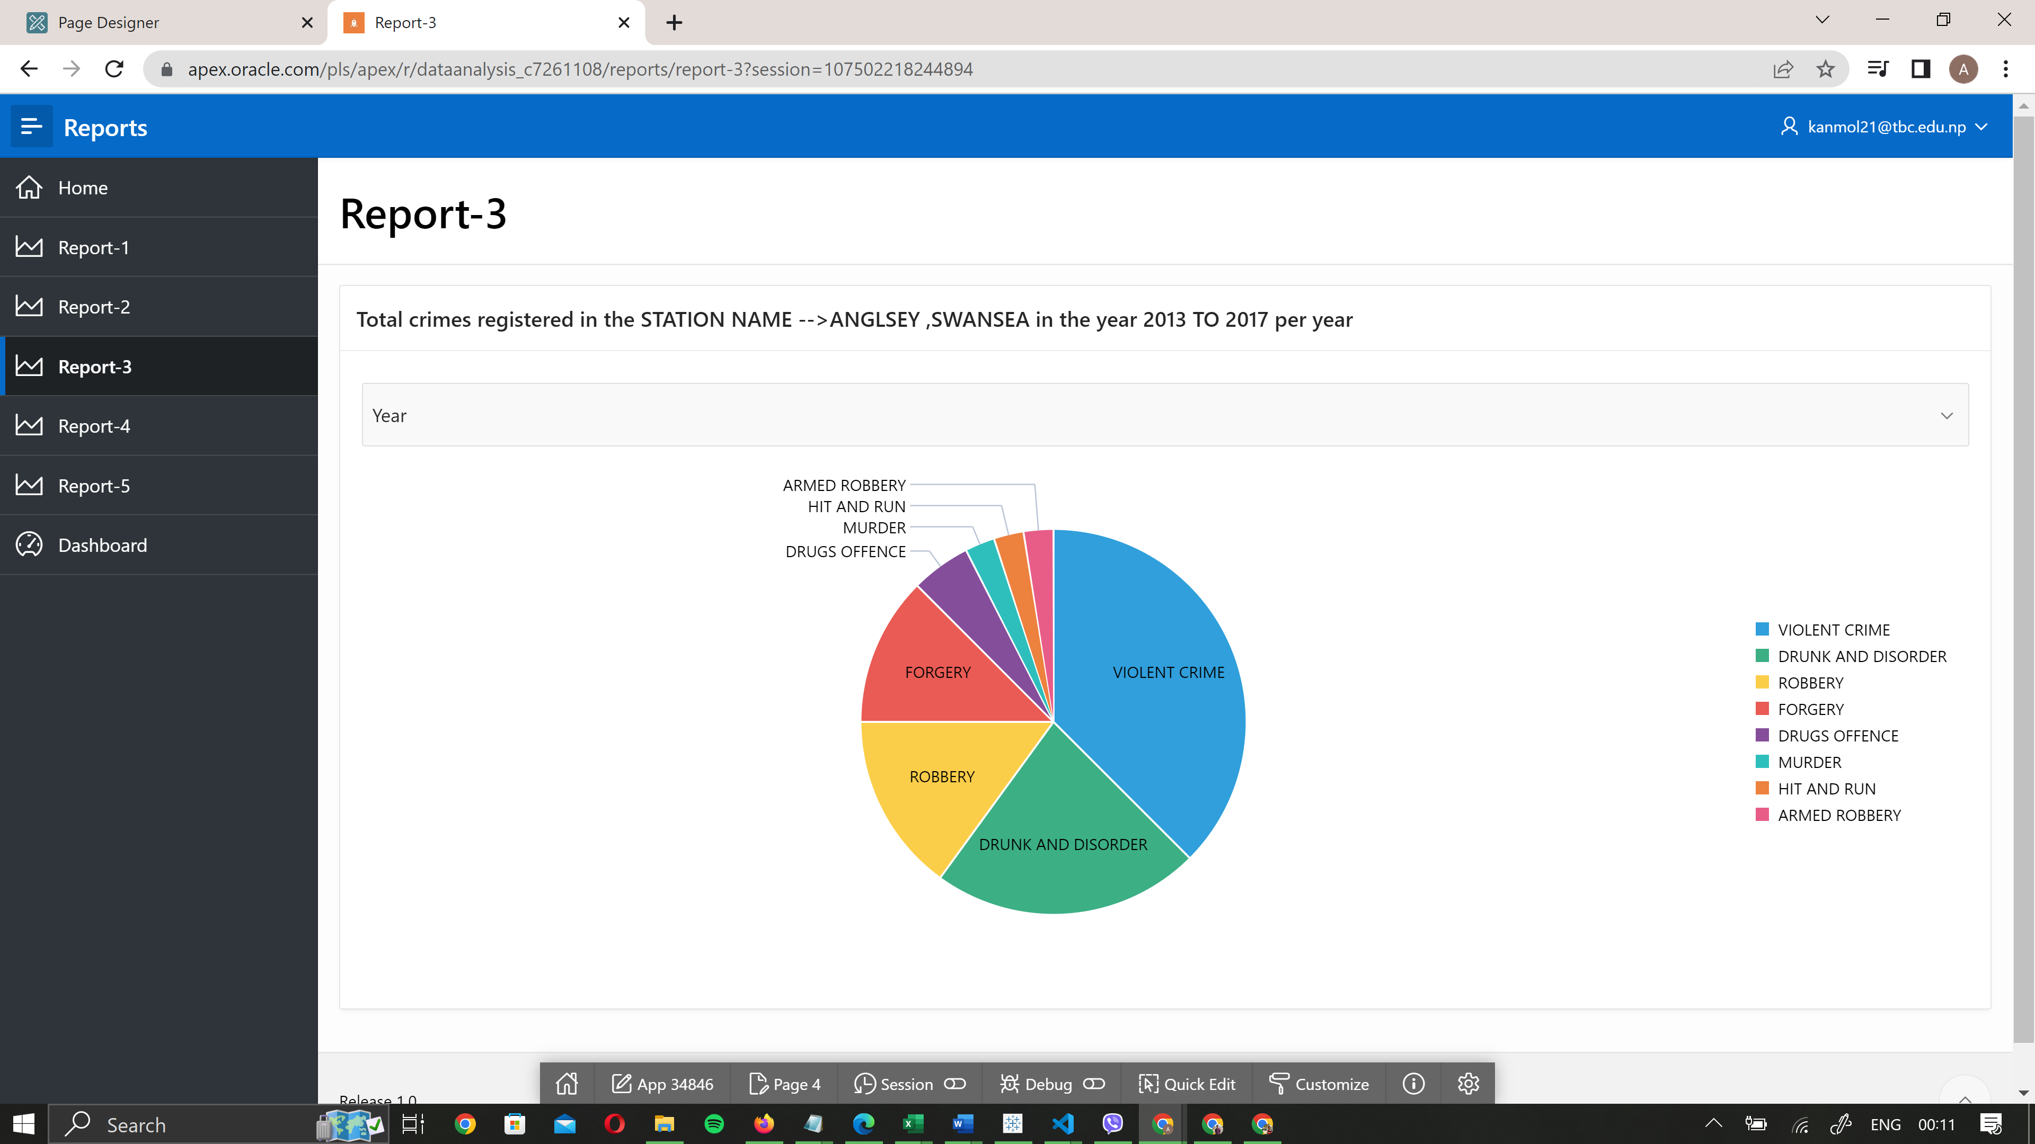

**DESCRIPTION**

The above pie chart shows that the crime is registered in station named Anglsey and Swansea between year 2013 to 2017. The text inside pie chart indicates the crime type with its color. The color information is shown in legend.

***REPORT 4: CRIME SOLVING RATE OF EACH STATION***

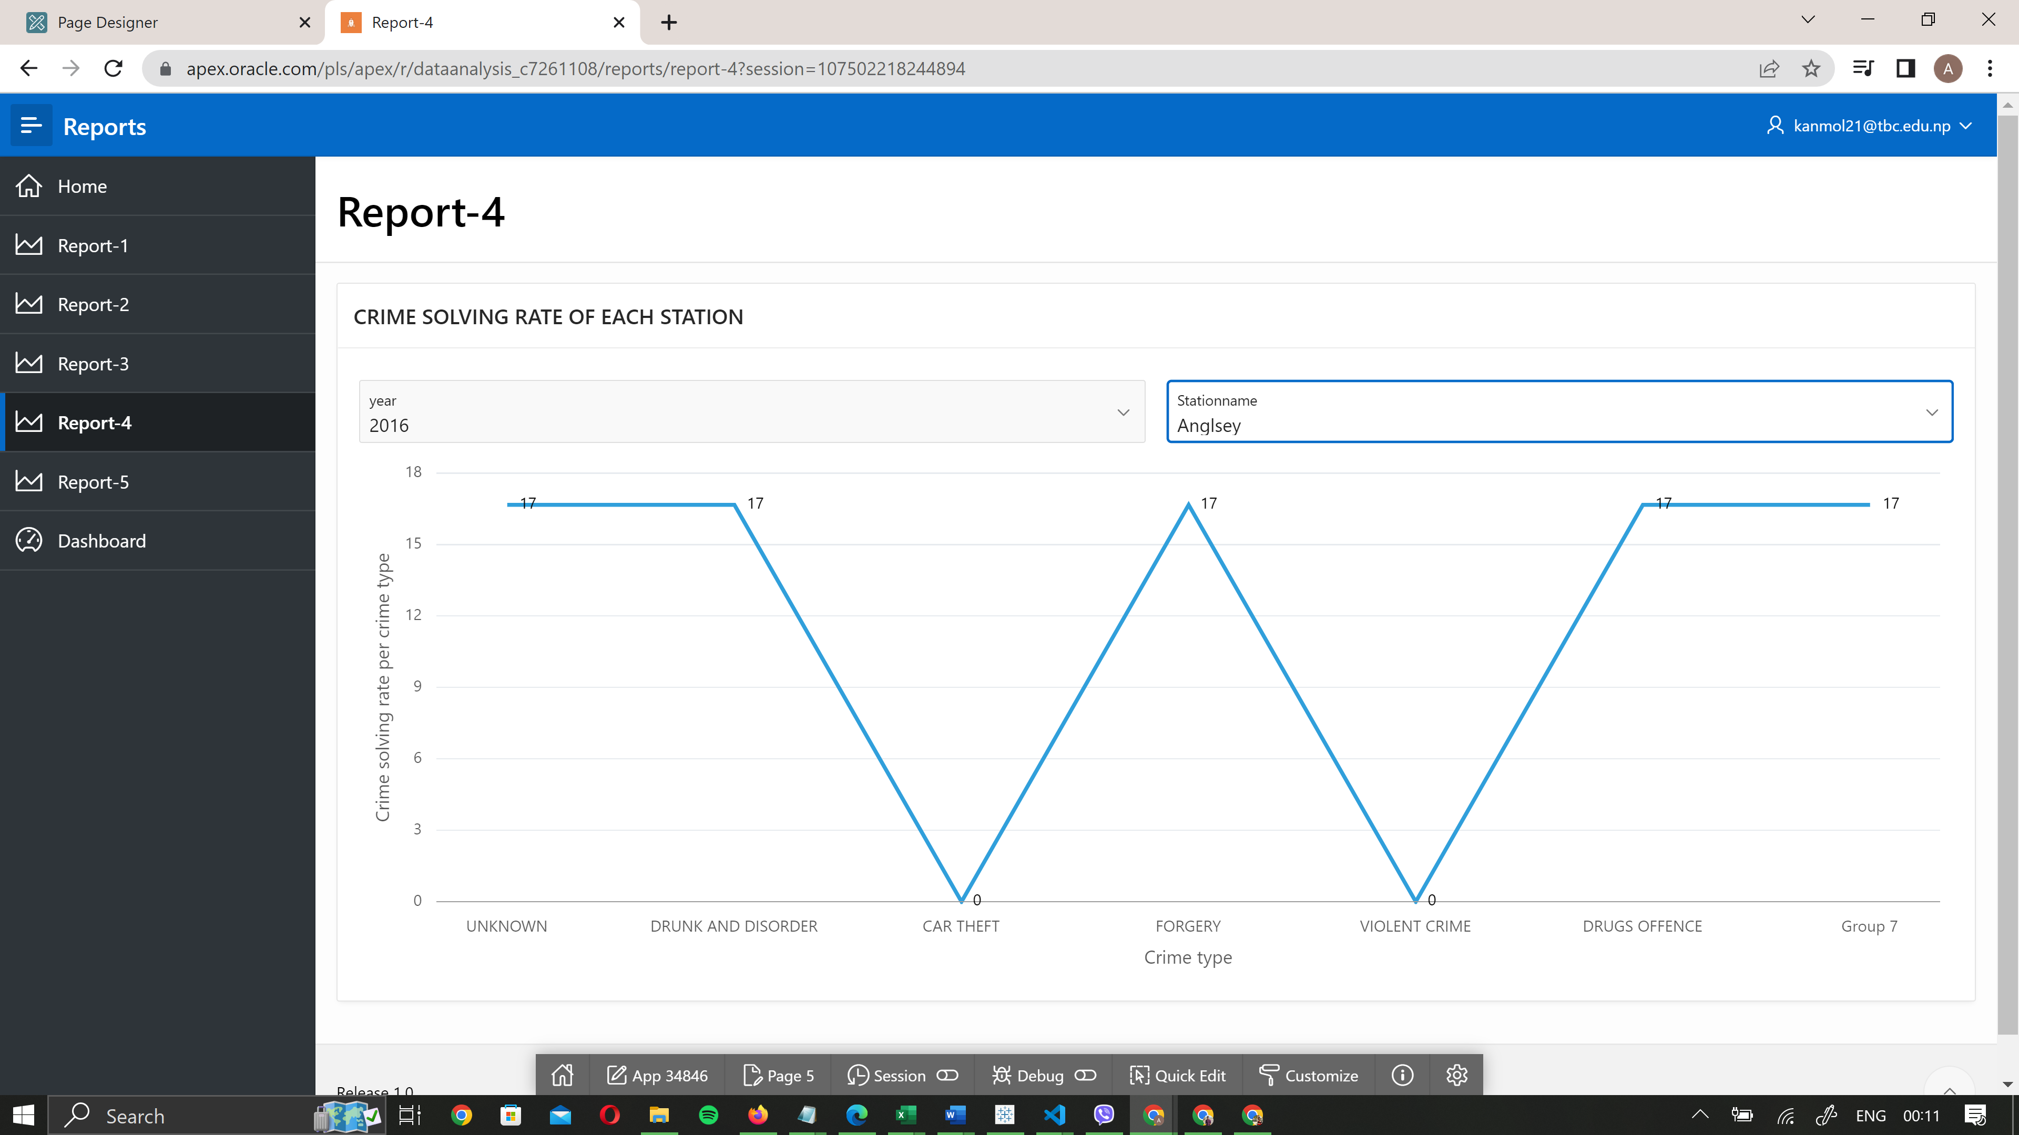

**DESCRIPTION**

The above chart shows the crime solving rate of each station in some given specific year. The crime solving rate is given by total number of crime registered divided by solved crime multiplied by 100. The data in y axis is crime solving rate where as in y axis it shows crime type . The two drop down fields above is kept there to filter data with station name and year. Thus this chart shows the solving rate of each station.

***REPORT 5:-Number of closed crimes type per year of the current year (2017) and the previous year(2016) with respect to each crime location***

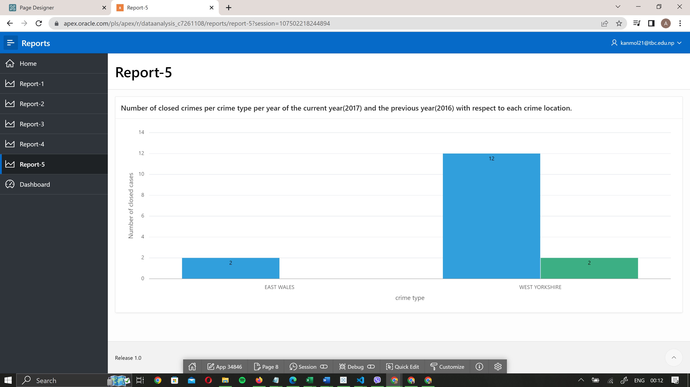

**DESCRIPTION**

The above chart shows the crime opened and closed in each location and comparing it with previous year data. The data is shown of 2016 and 2017

### **Tableau Reports and Charts**

***DASHBOARD***

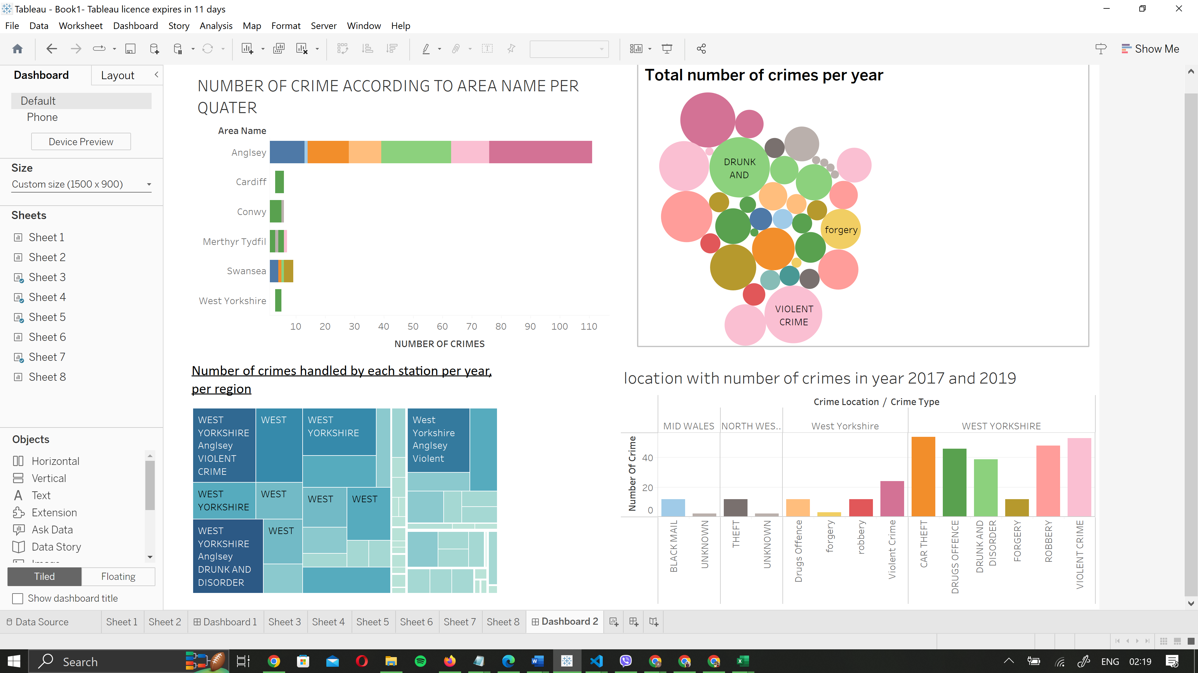

The reports presented below were created with Tableau software and are based on the data that was provided to us in order for us to complete this work.

***REPORT 1:- NUMBER OF CRIME ACCORDING TO CRIME TYPE AND CRIME LOCATION***

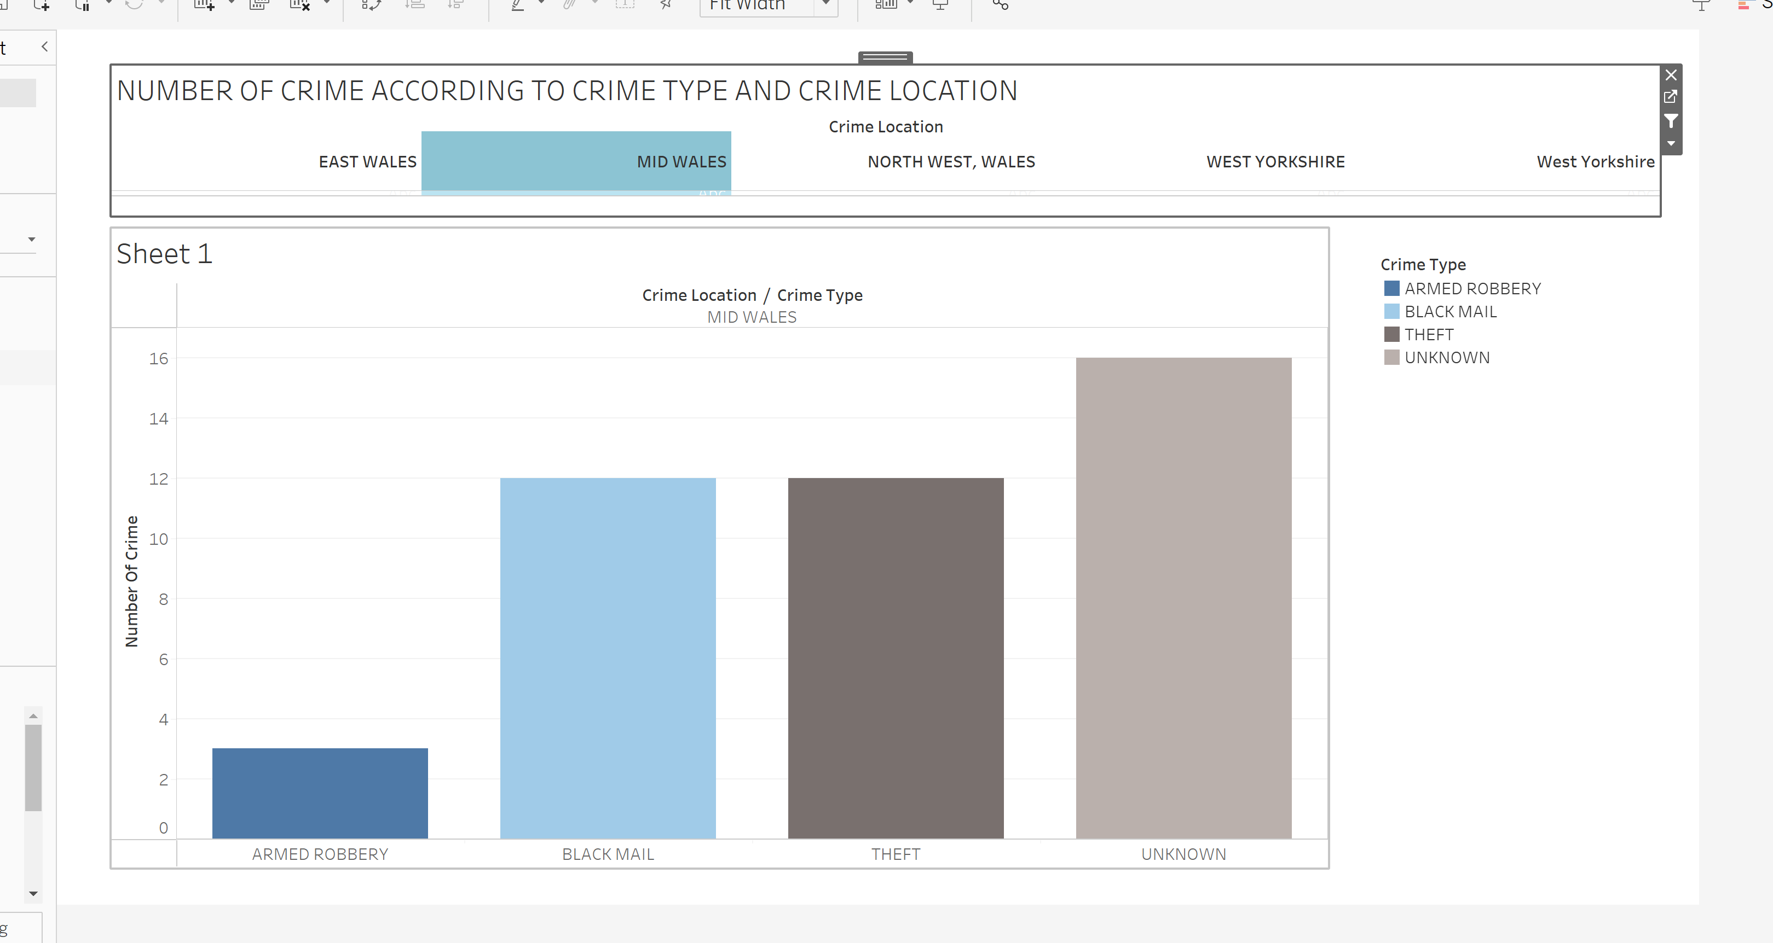

**DESCRIPTION:-**

The given chart shows number of crime according to crime types . Also used slicer for filtering location.

***REPORT 2:- NUMBER OF CRIME ACCORDING TO AREA NAME PER QUATER***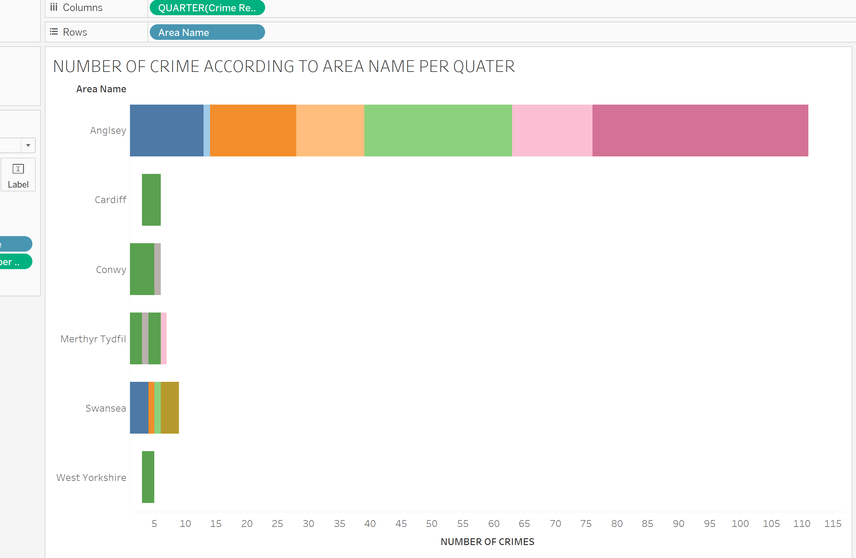

**DESCRIPTION**

The above chart shows number of crime according to area name per quarter

***REPORT 3 : Number of crime handled by each station per year, per region***

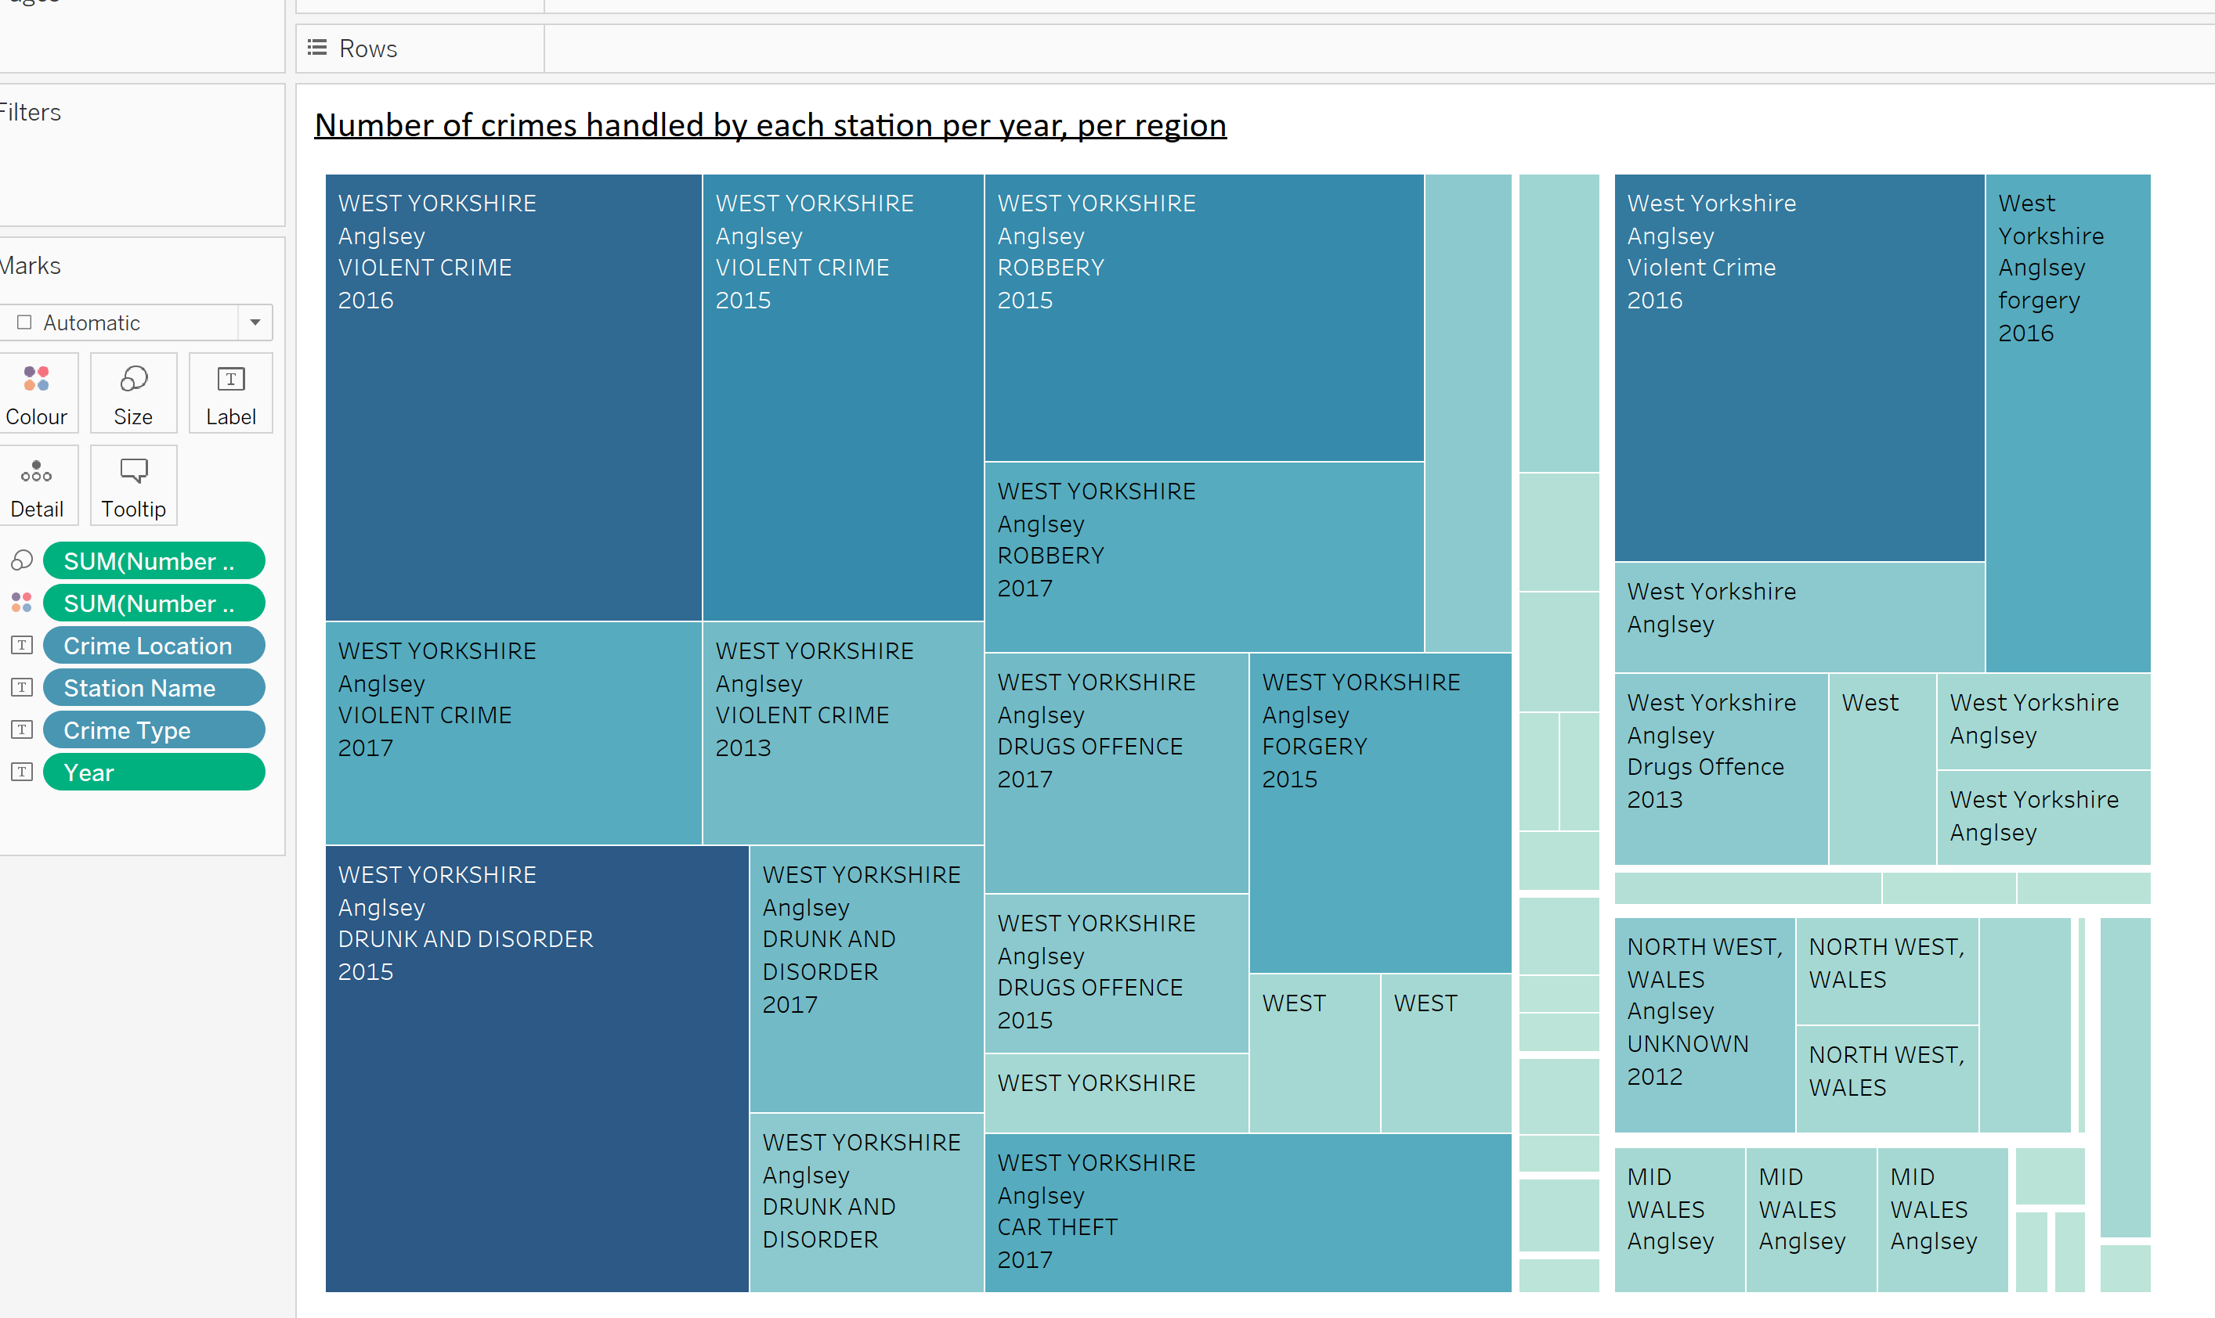

**DESCRIPTION**

The above chart shows number of crime handled by each station per year, per region.

***REPORT 4:- Location with number of crimes in year 2017 and 2019***

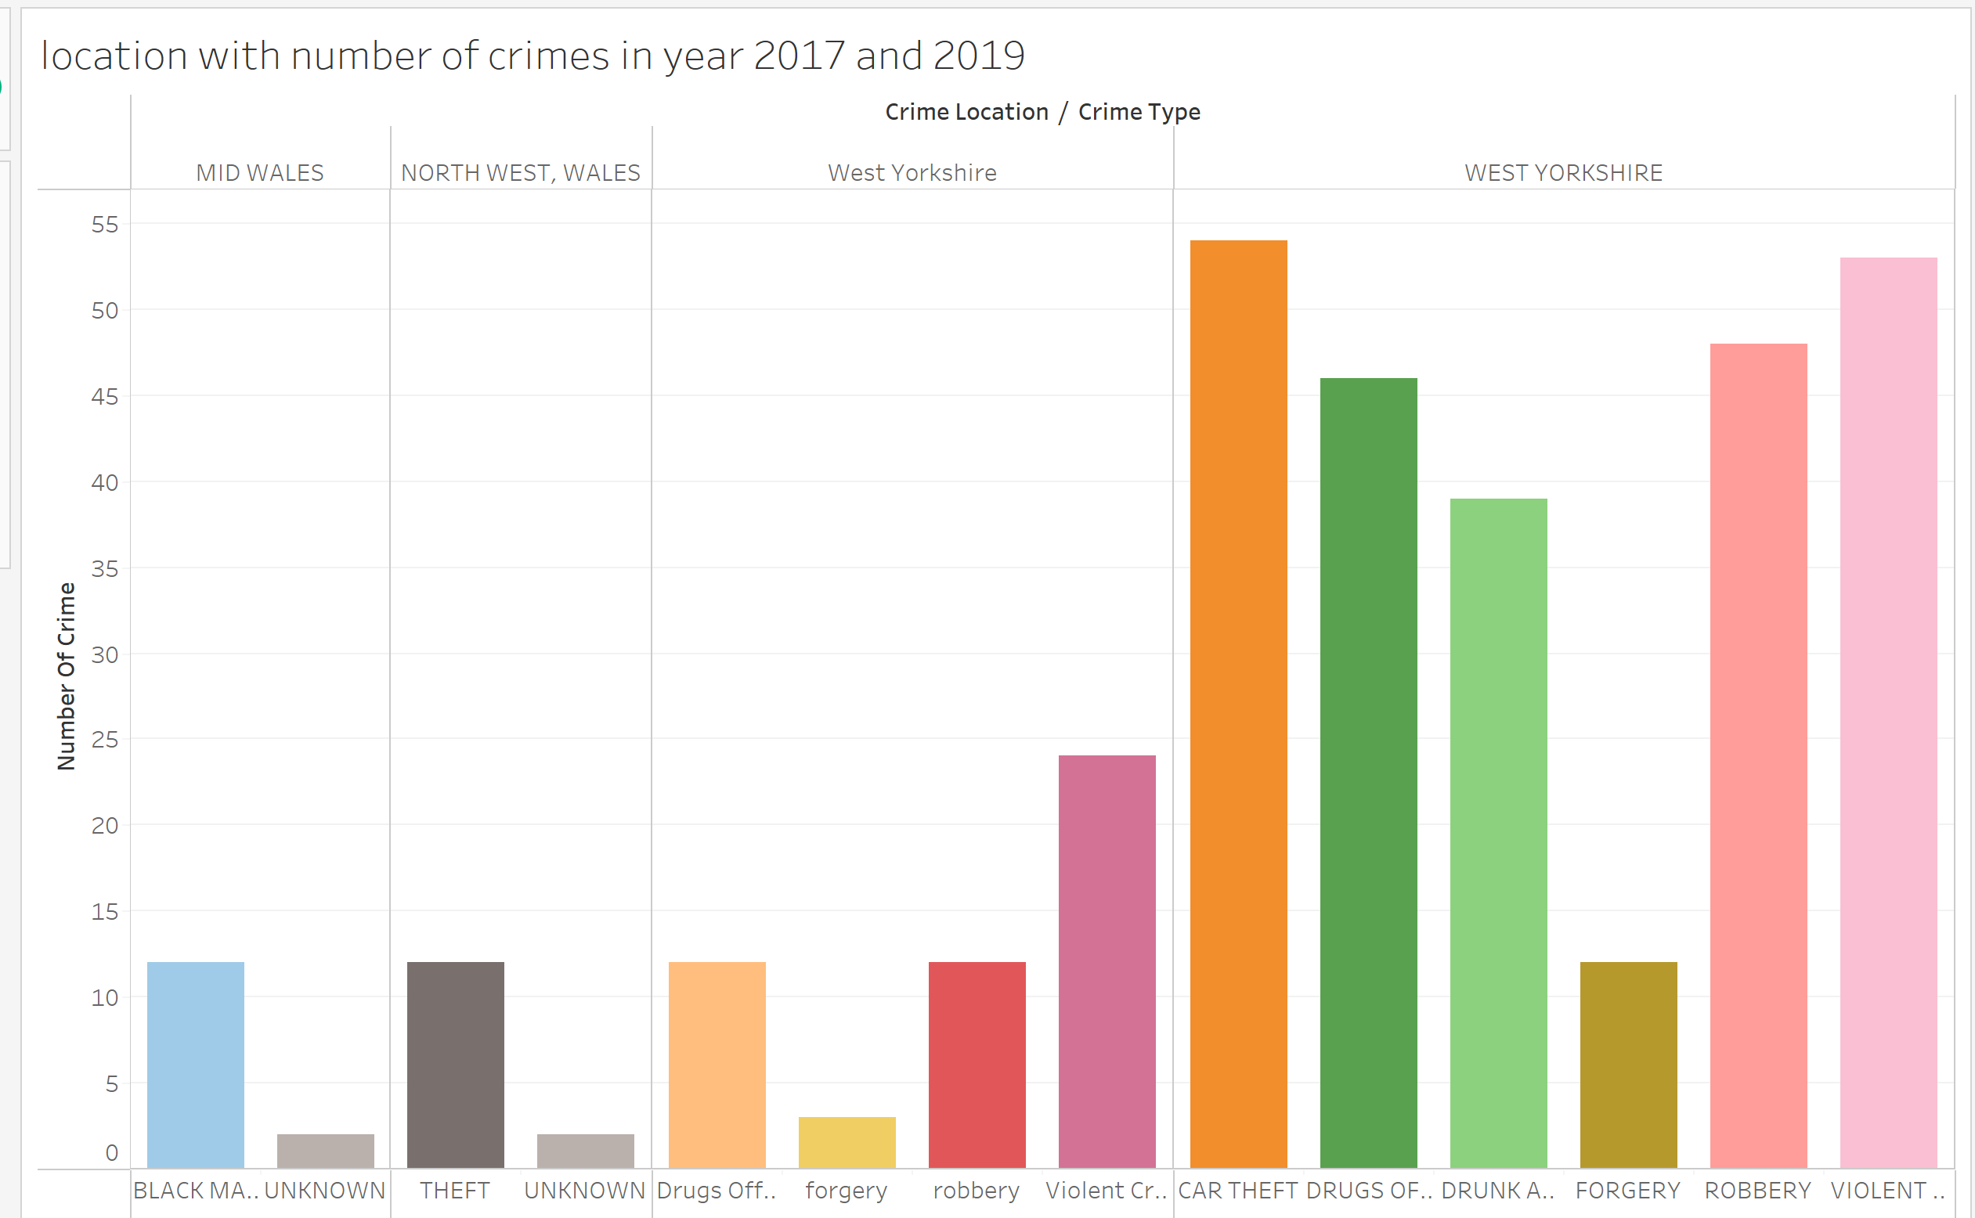

**DESCRIPTION**

This above chart shows location with number of crimes in year 2017 and 2019.

***REPORT 5:- Total number of crimes per year***

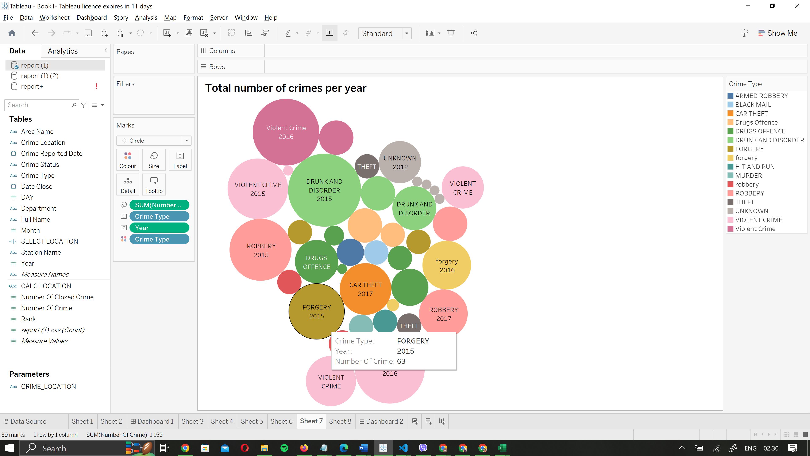

**DESCRIPTION**

The above chart shows total number of crime per year

**TASK 2 : Take your design and code further by using PL/SQL techniques**

1. Identify, code, test a function, procedure and package to support the ETL task.

***Creating packages for dimensional table***

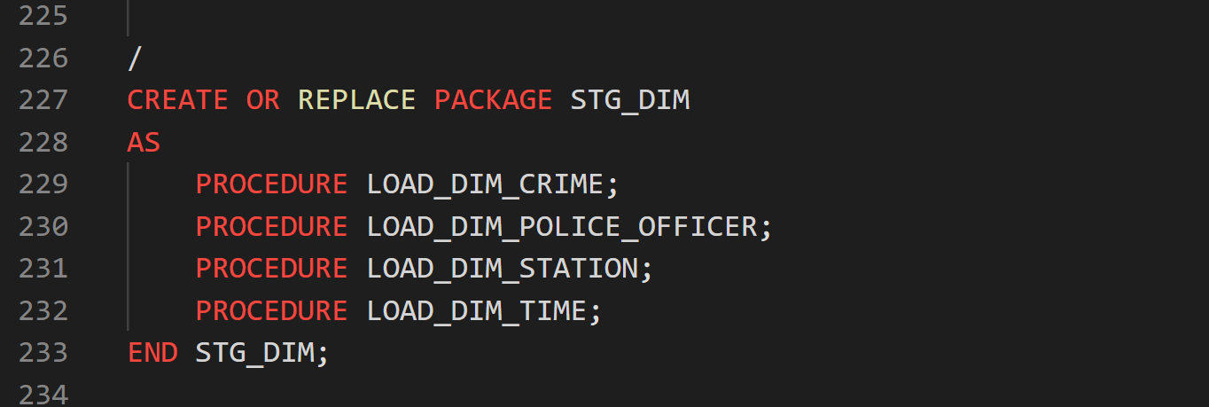

FIGURE:- CREATING PACKAGE

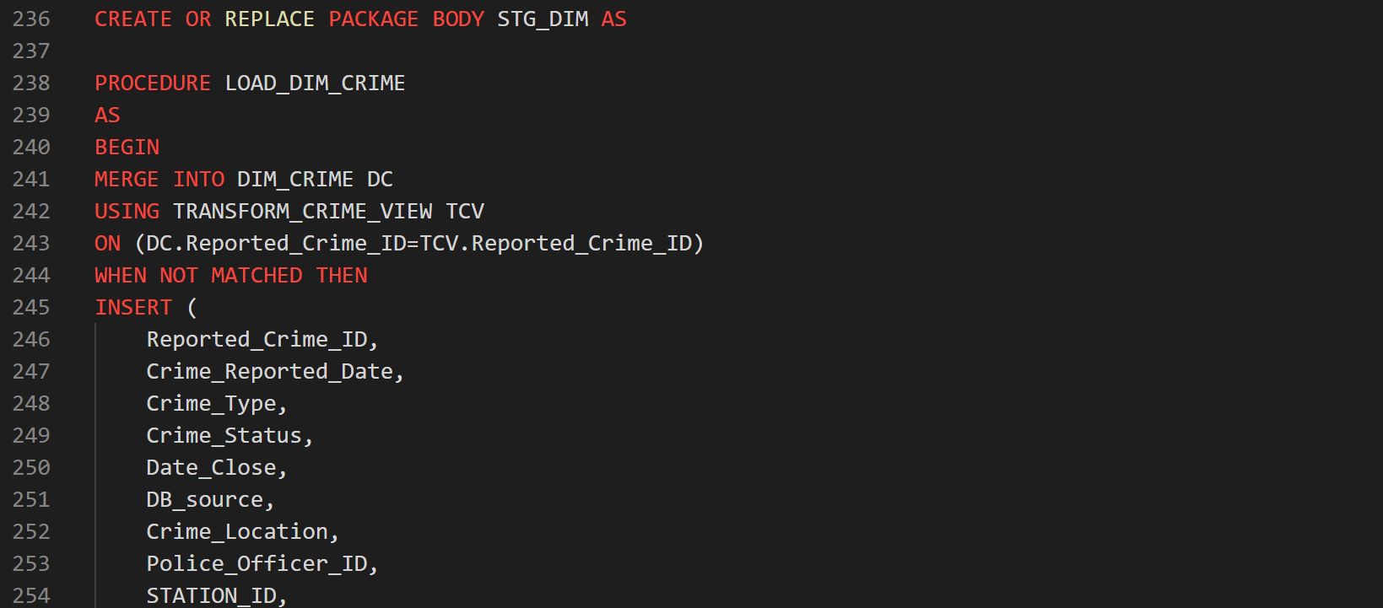

FIGURE:- CREATING PACKAGE BODY

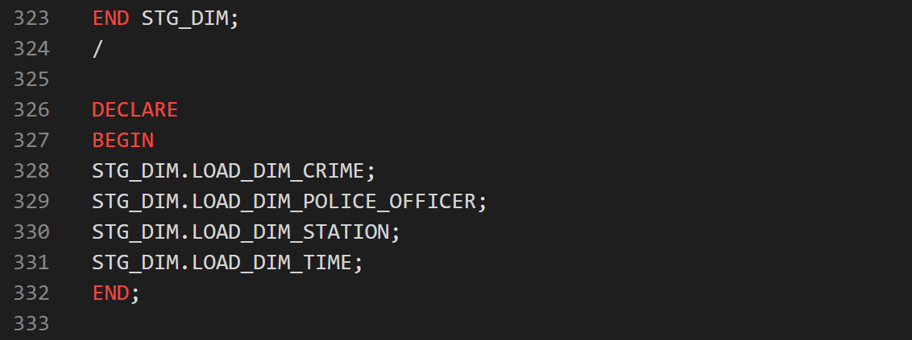

FIGURE:- RUNNING PROCUDURE AND FUNCTIO INSIDE PACKAGE

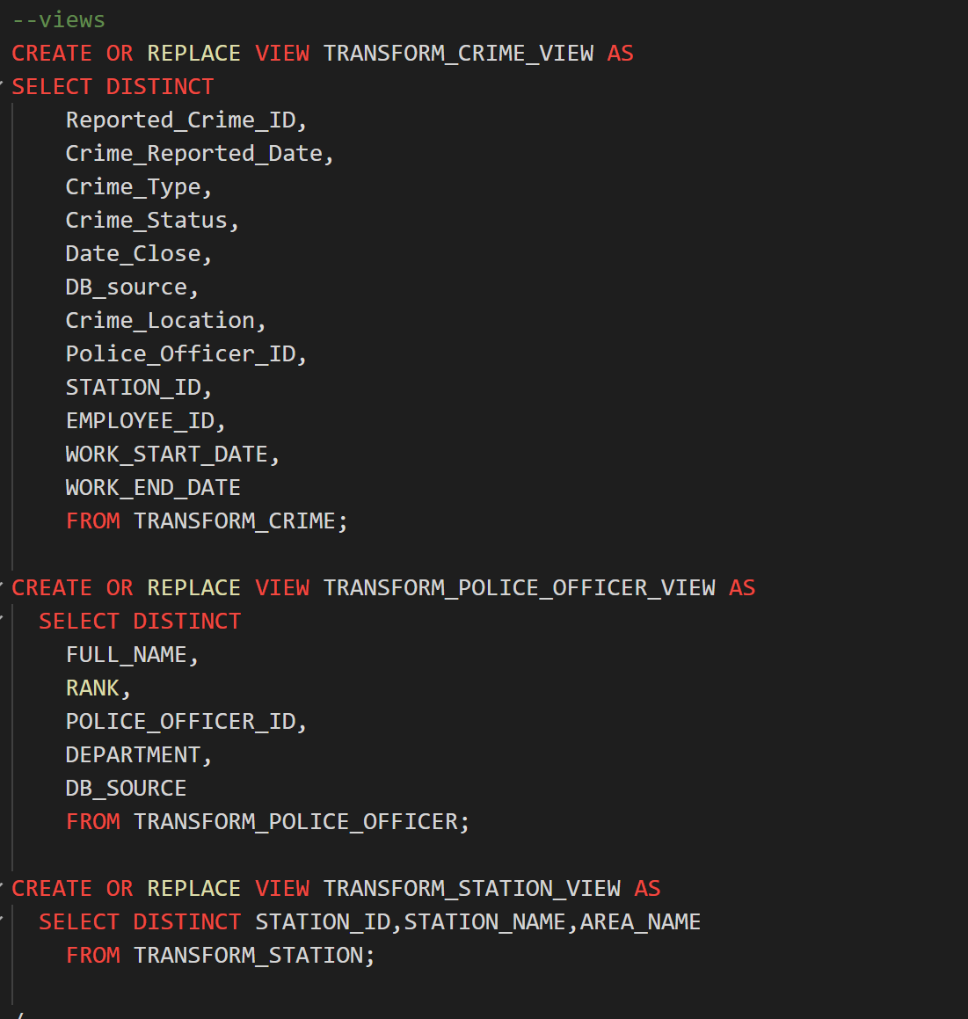

FIGURE:- CREATING VIEWS FOR DIMENSION TABLES

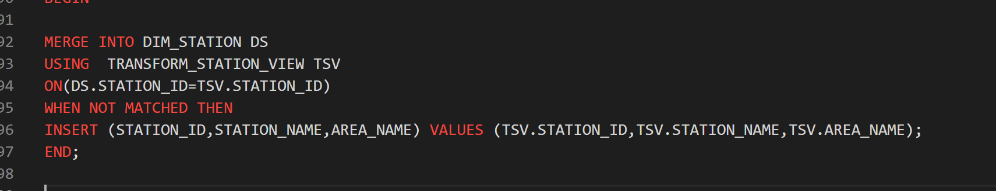

FIGURE:-EXAMPLE OF USING VIEW IN MERGE STATEMENT

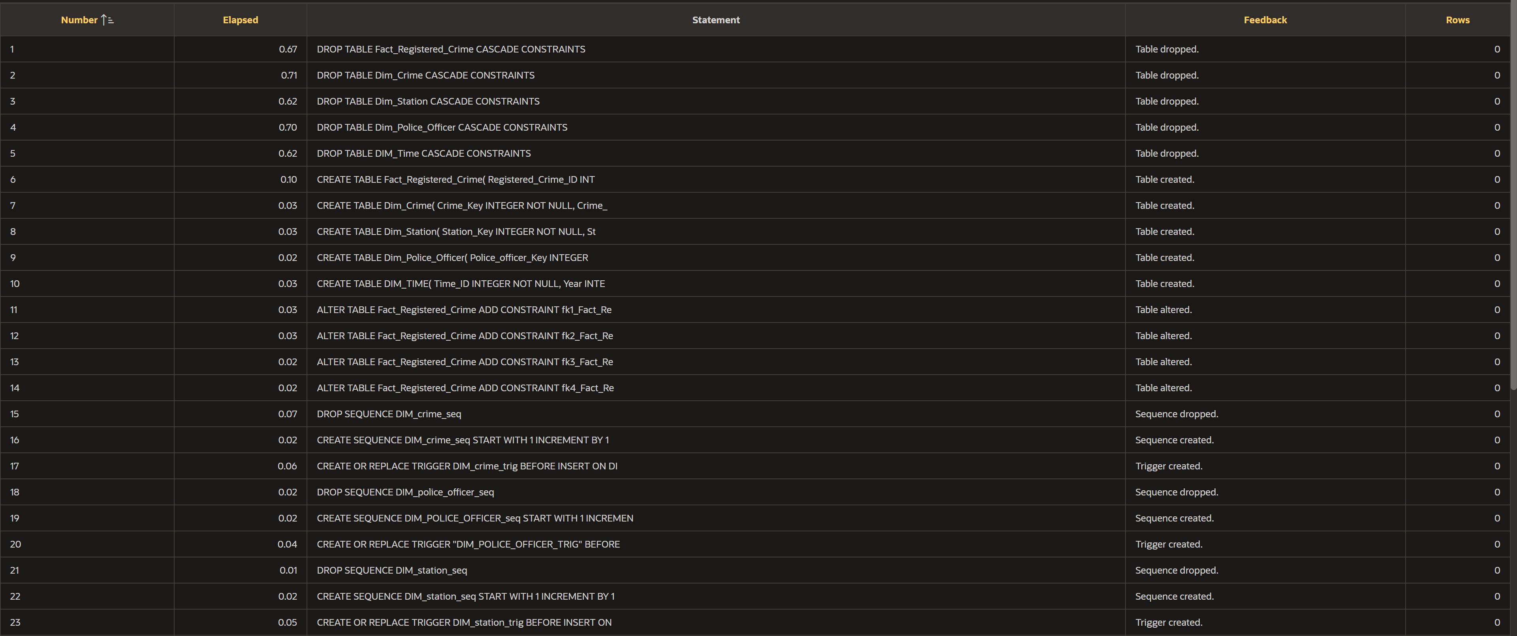

FIGURE:- EVIDENCE OF CREATING PACKAGE

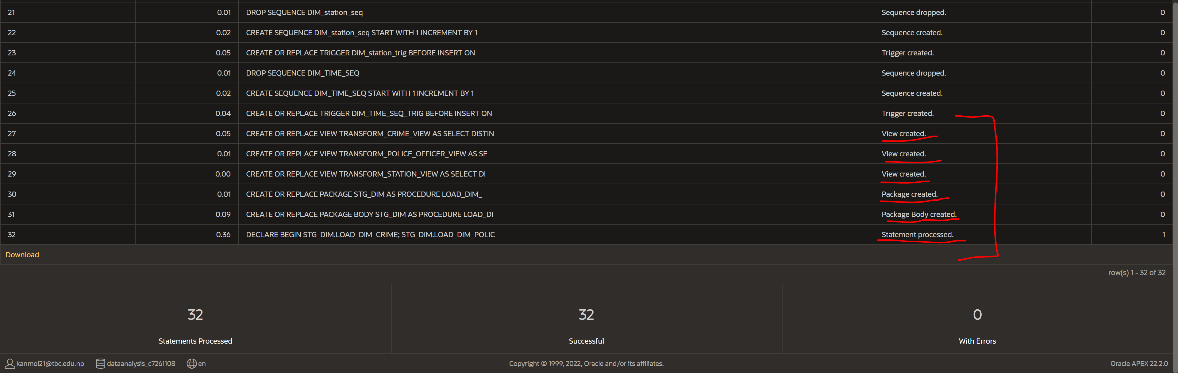

FIGURE:- EVIDENCE OF CREATING PACKAGE

Creating packages for good bad table

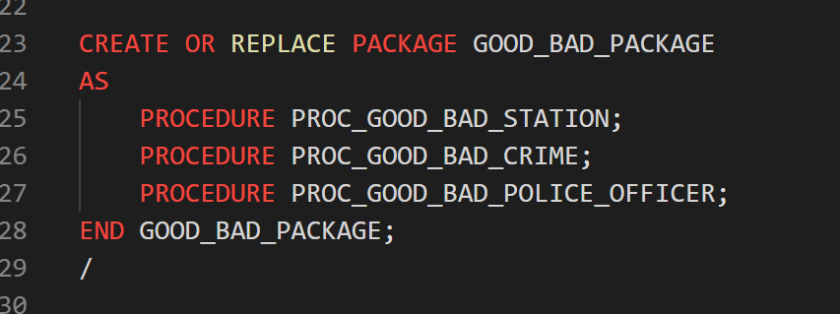

FIGURE:- CREATING PACKAGE

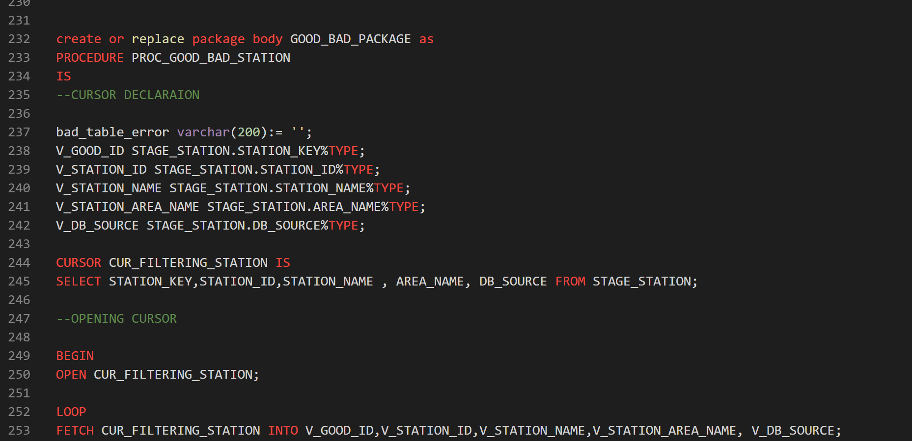

FIGURE :- CREATING PACKAGE BODY

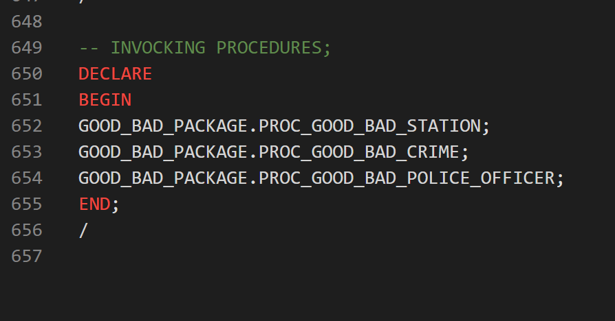

FIGURE:- INVOCKING PROCEDURES

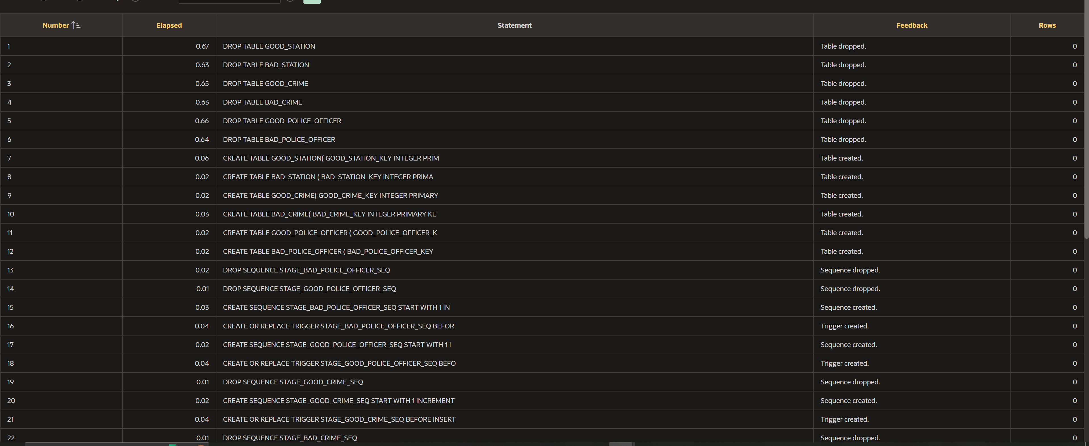

FIGURE:- EXECUTING PACKAGES

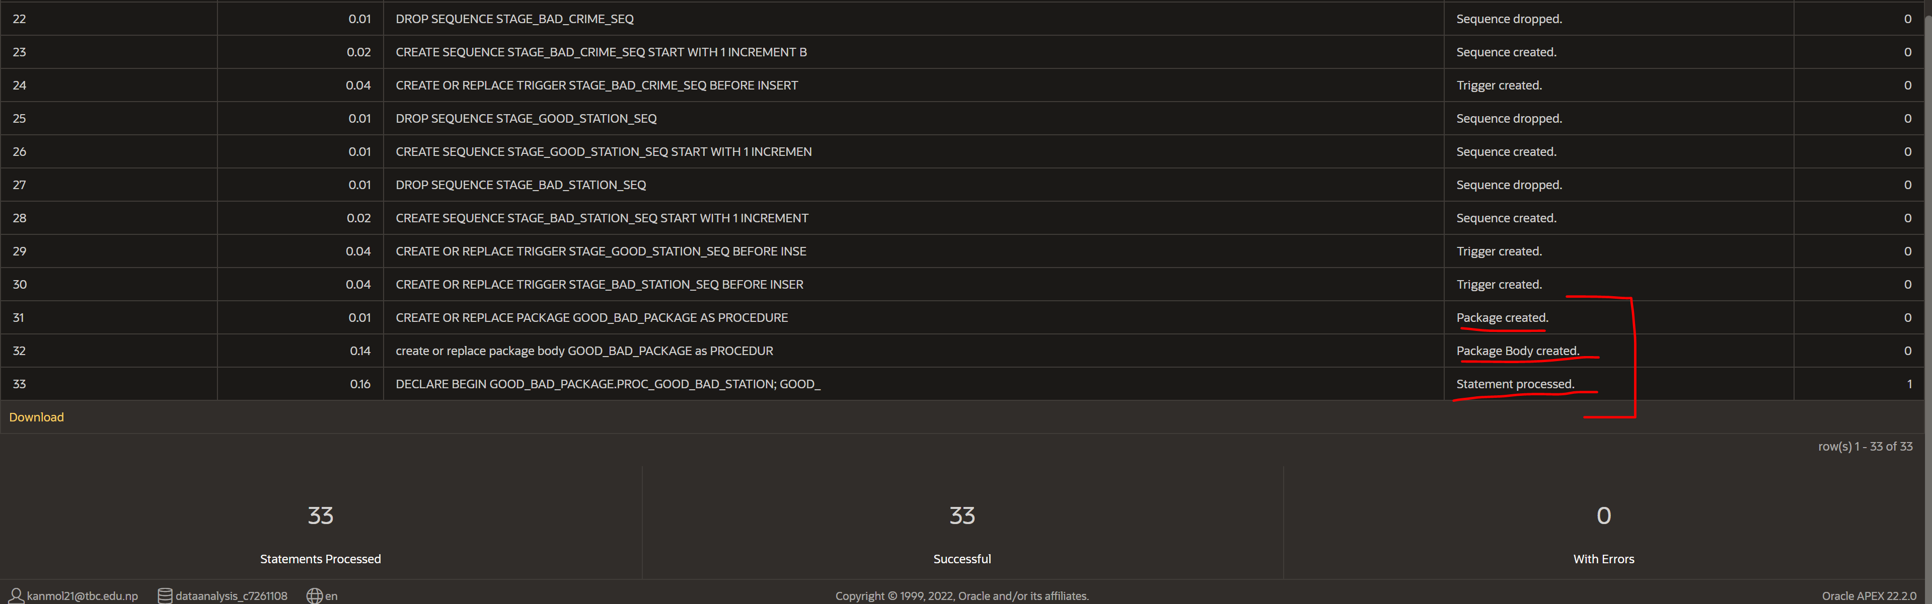

FIGURE:- EXECUTING PACKAGES

Creating packages for **stage** table

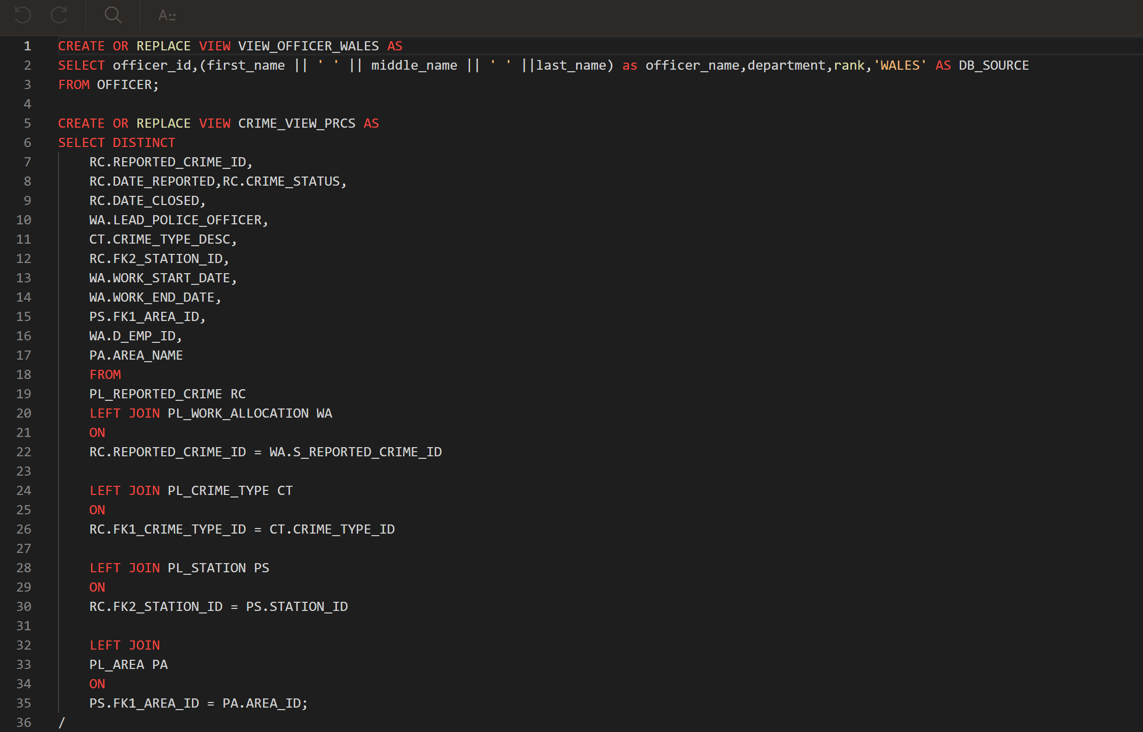

FIGURE:- CREATING VIEWS FOR STAGE TABLE

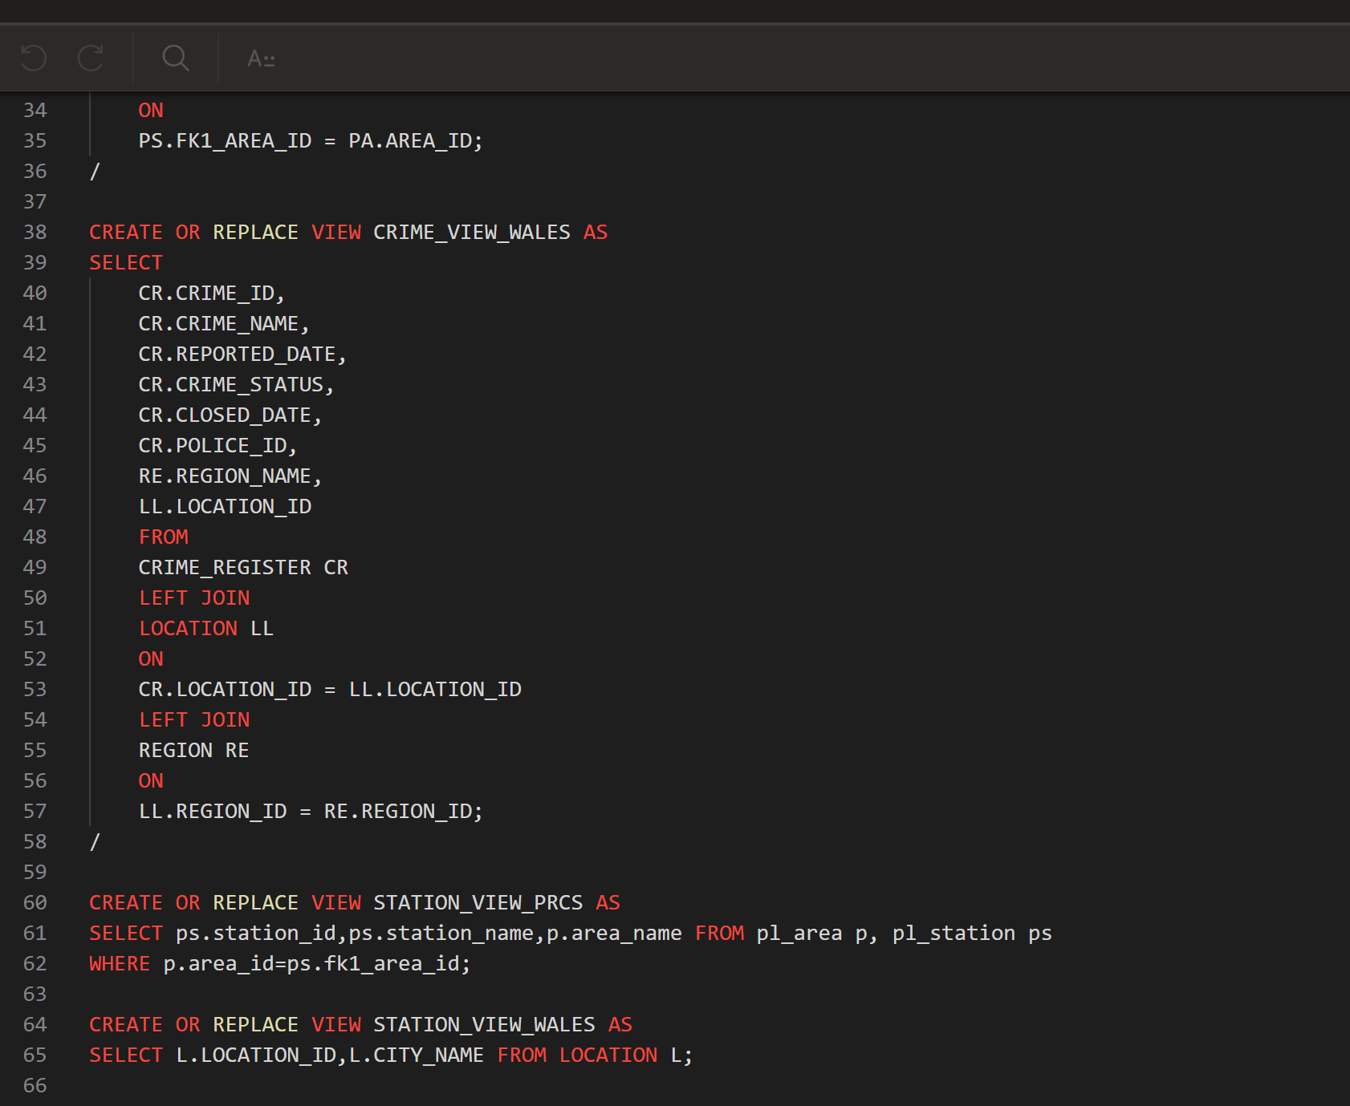 FIGURE:- CREATING VIEWS FOR STAGE TABLE

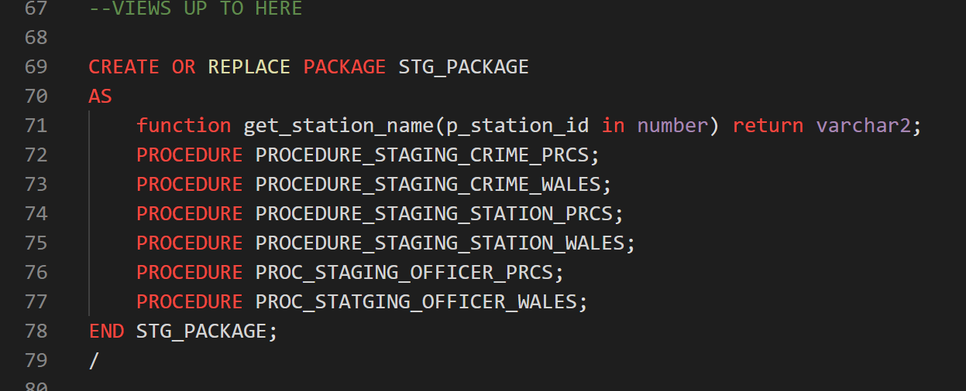

FIGURE:- CREATING PACKAGE

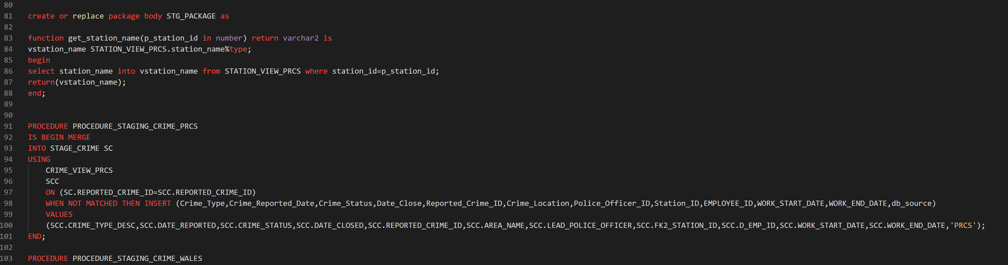

FIGURE:- CREATING PACKAGE BODY

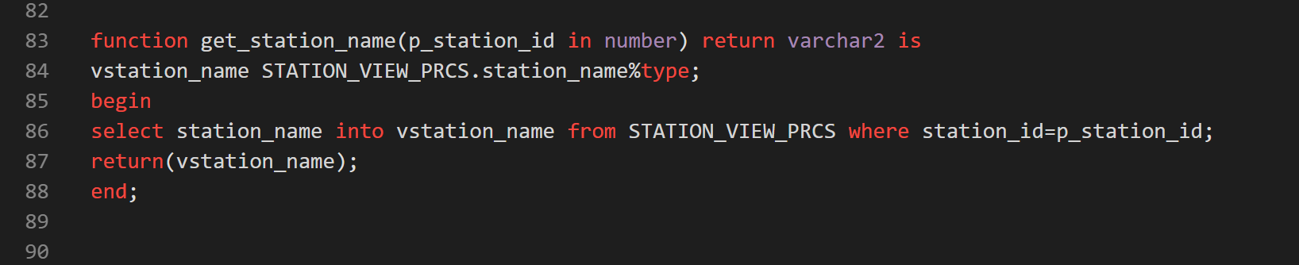

FIGURE:- CREATING FUNCTION

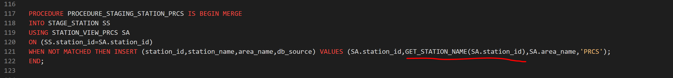

FIGURE:- USING FUNCTION IN PROCEDURE

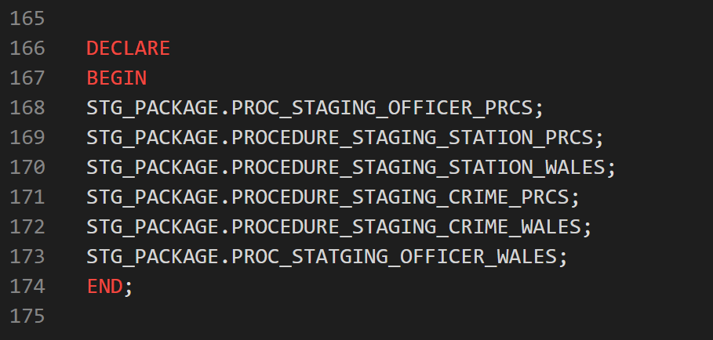

FIGURE:- INVOCKING PROCUDURES AND FUNCTION IN PACKAGE

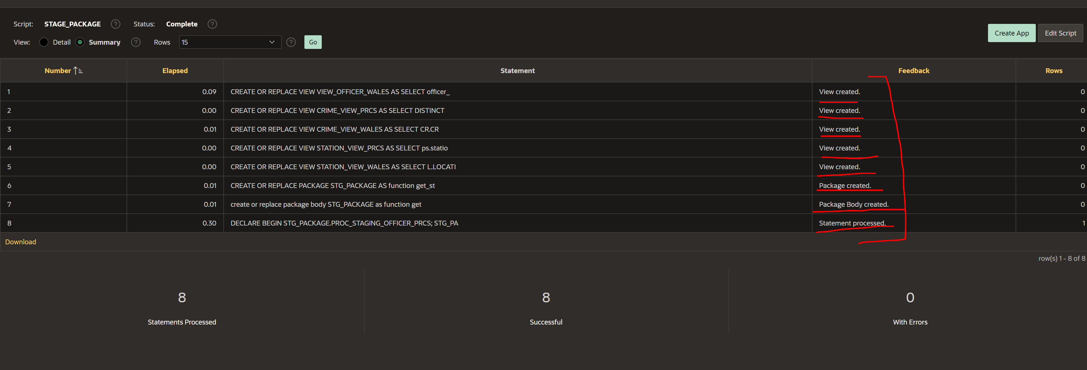

FIGURE:- EVIDENCE OF CREATING, PROCESSING PACKAGE AND VIEW

Creating packages for transform table

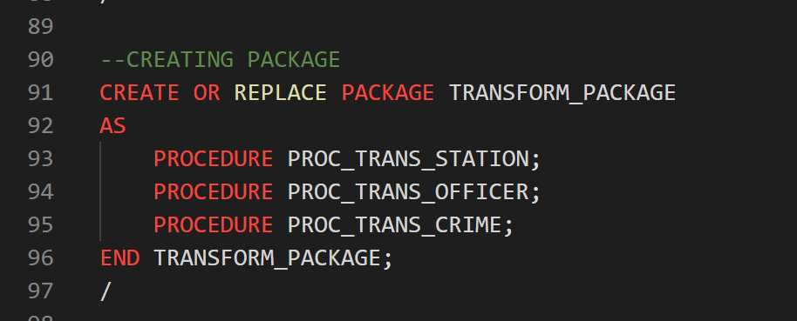

FIGURE:- CREATING PACKAGE

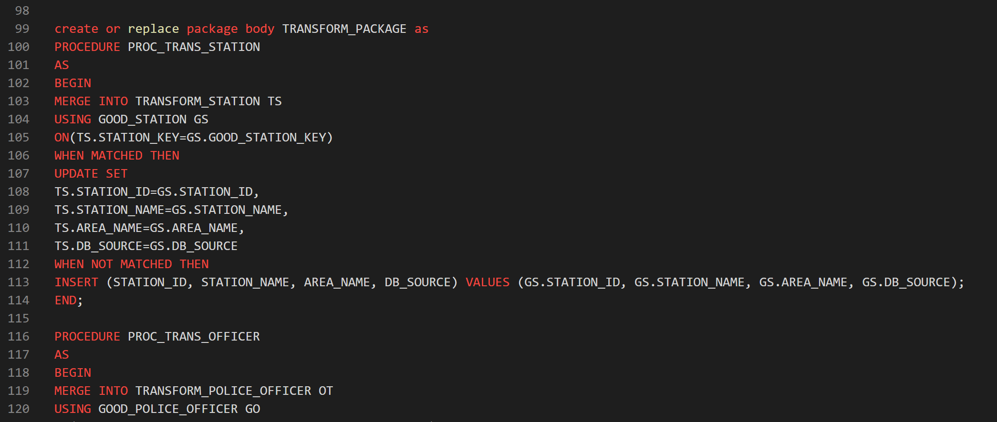

FIGURE :- CREATING PACKAGE BODY

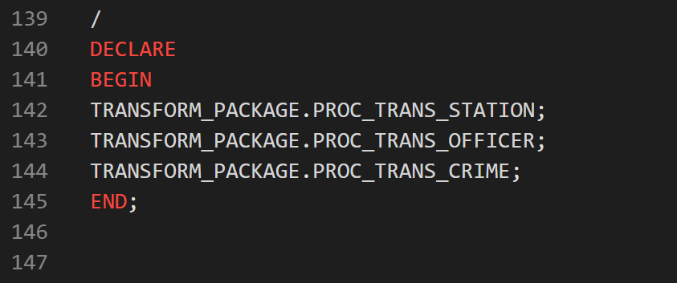

FIGURE:-INVOCKING PROCEDURES INSIDE PACKAGE

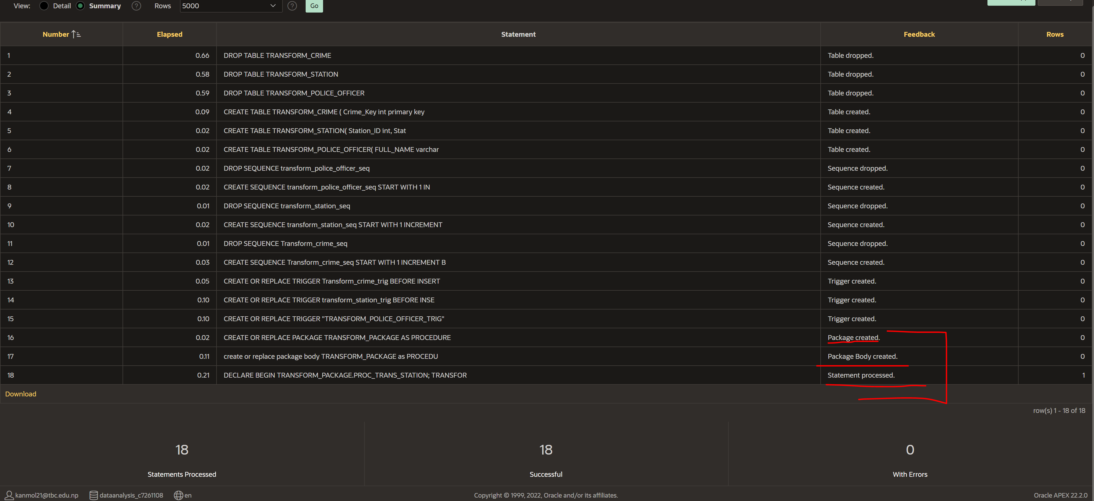

FIGURE:- EVIDENCE OF CREATING AND RUNNING PACKAGE

Creating packages for fact table

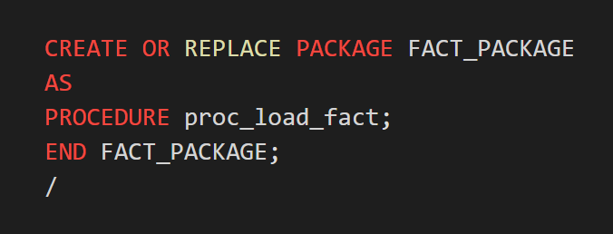

FIGURE:- CREATING PACKAGE

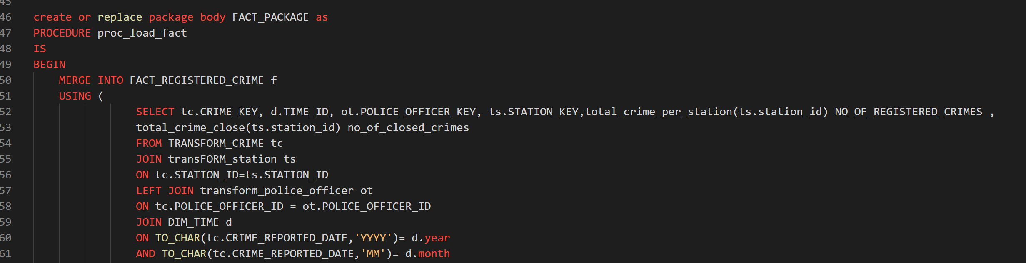

FIGURE:- CREATING PACKAGE BODY

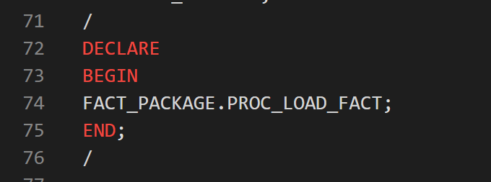

FIGURE:- INVOCKING PROCEDURE INSIDE PACKAGE

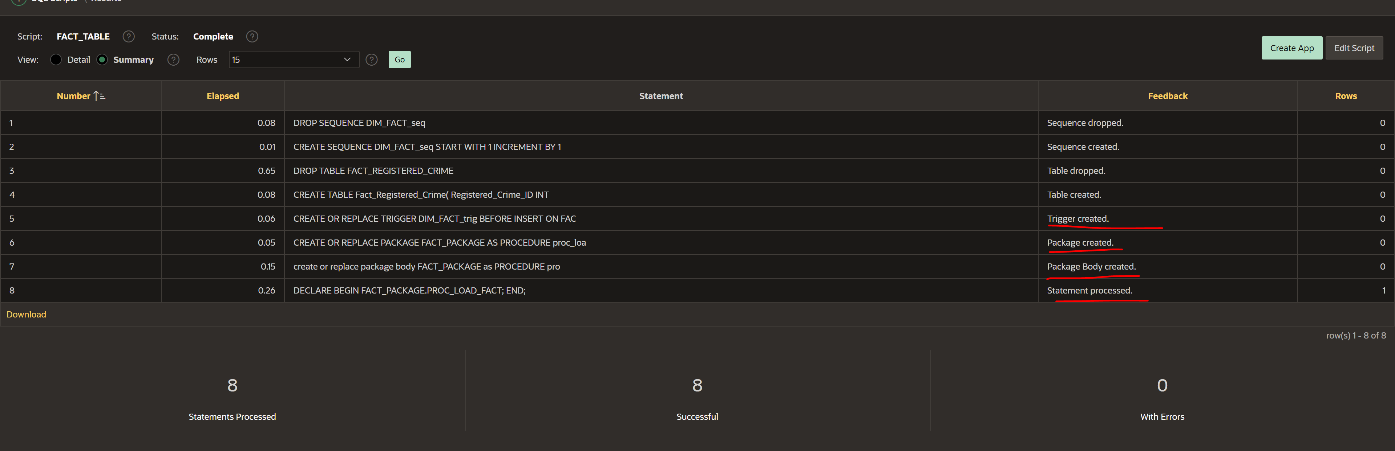

FIGURE:- EVIDENCE OF CREATING PACKAGE AND RUNNIG PACKAGE

Successfully inserting data using package

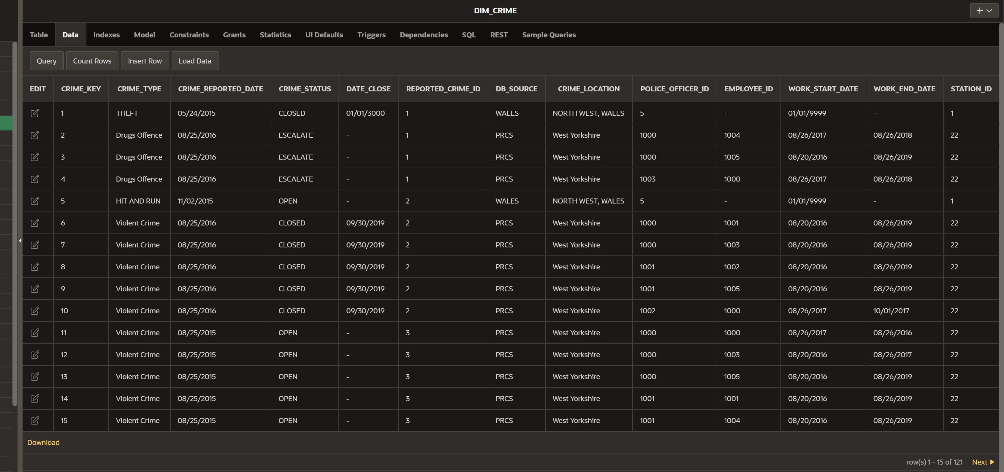

FIGURE:- INSERTING DATA INTO DIM_CRIME USING PACKAGE

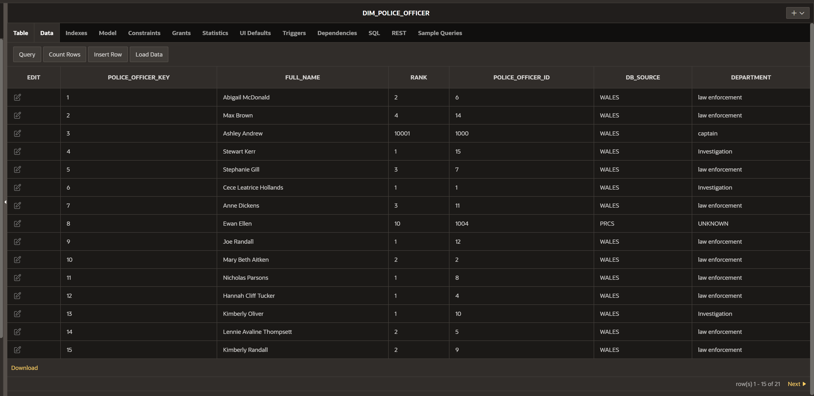FIGURE:- INSERTING DATA INTO DIM_POLICE_OFFICER USING PACKAGE

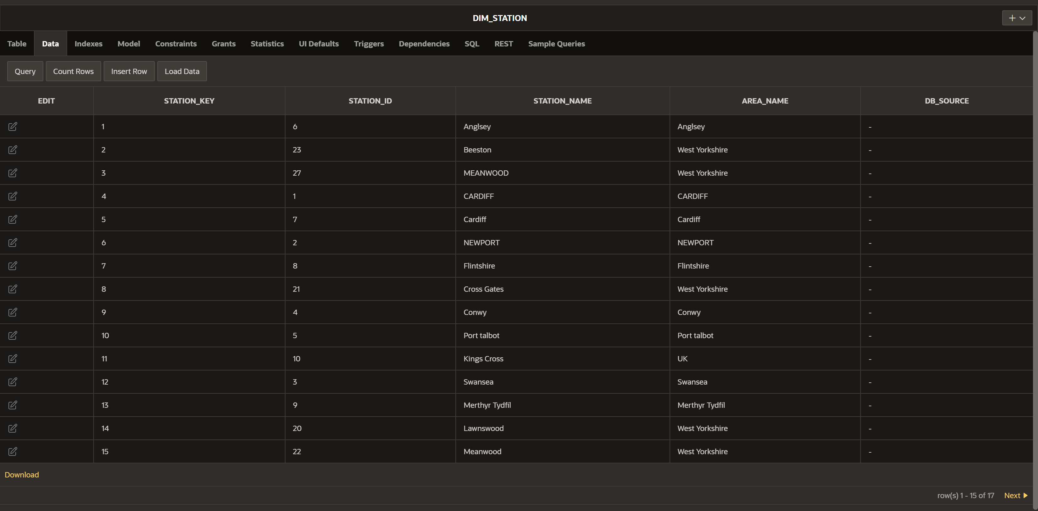

FIGURE:- INSERTING DATA INTO DIM_STATION USING PACKAGE

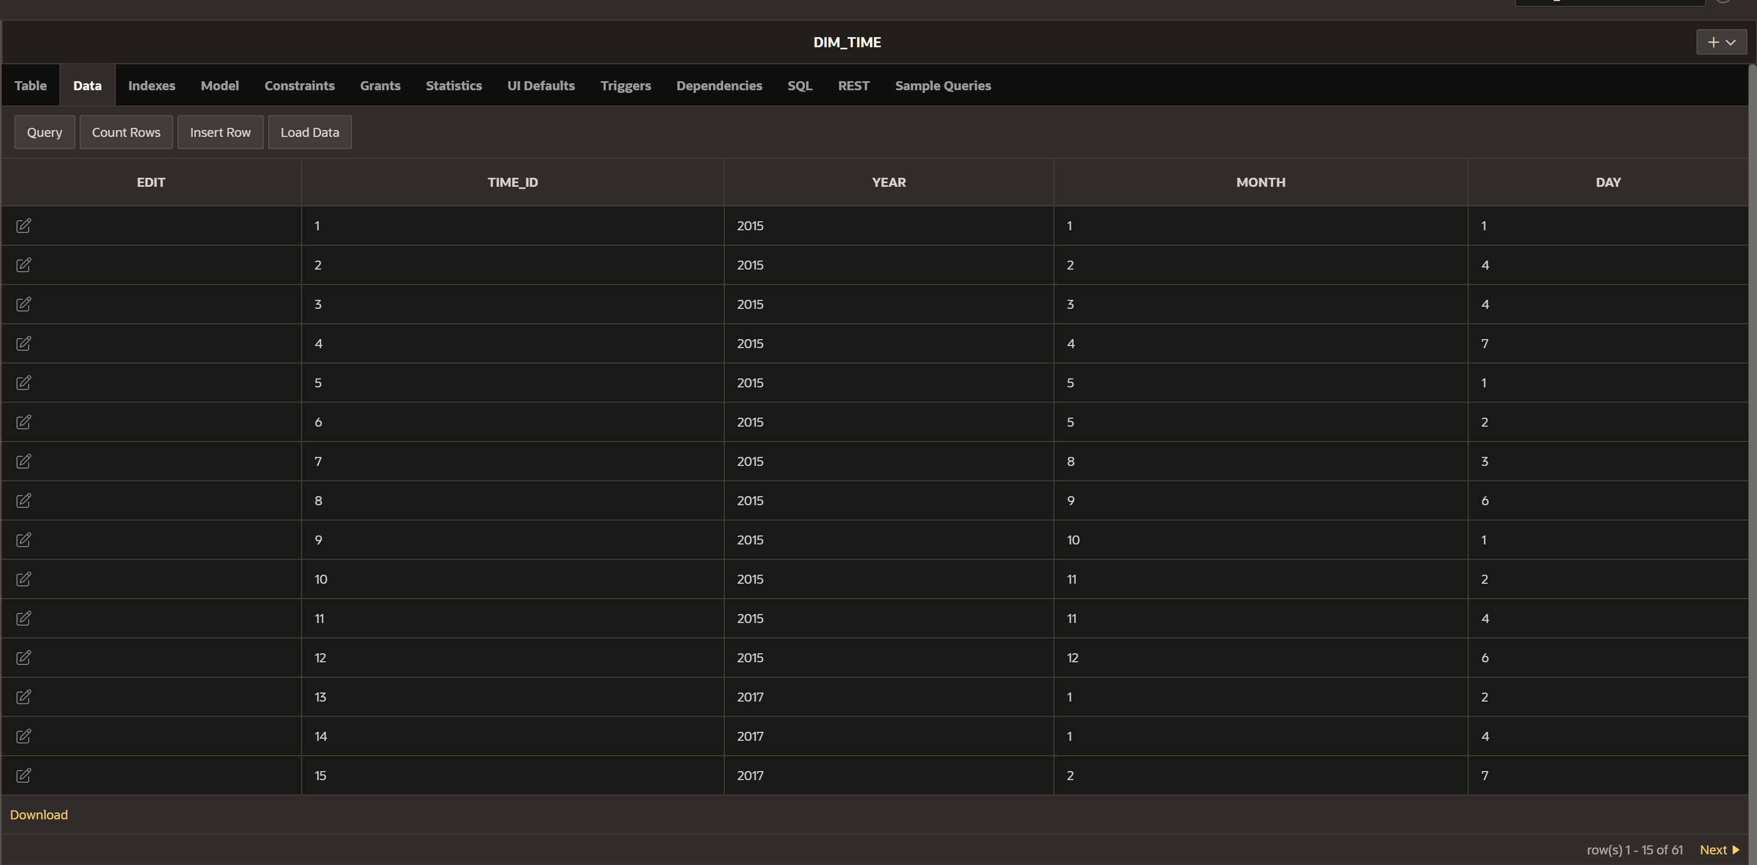

FIGURE:- INSERTING DATA INTO DIM_TIME USING PACKAGE

# Bibliography

Dancuk, M. (2021, June 8). *OLTP vs OLAP: A Comprehensive Comparison*. Retrieved January 3, 2022, from https://phoenixnap.com/kb/oltp-vs-olap

FRANKENFIELD, J. (2021, September 04). *Data Analytics*. Retrieved January 4, 2022, from Investopedia: https://www.investopedia.com/terms/d/data-analytics.asp

iDashboards. (2019). *What is The Purpose of a Dashboard?* Retrieved 01 08, 2020, from https://www.idashboards.com/blog/2016/09/26/what-is-the-purpose-of-a-dashboard-2/

INDRAJITH. (2021, February 7). *Inmon vs Kimball - the great data warehousing debate*. Retrieved January 3, 2022, from Cloud Zone: https://medium.com/cloudzone/inmon-vs-kimball-the-great-data-warehousing-debate-78c57f0b5e0e

Johnson, D. (2021, December 11). *What is Data Analysis? Research | Types | Methods | Techniques*. Retrieved January 3, 2022, from guru99: https://www.guru99.com/what-is-data-analysis.html

Microsoft. (2021, August 12). *Dashboards for business users of the Power BI service*. Retrieved January 4, 2022, from Microsoft: https://docs.microsoft.com/en-us/power-bi/consumer/end-user-dashboards

S, V. (2020, December 20). *Various Data Warehouse Design Approaches*. Retrieved January 3, 2022, from dwgeek : https://dwgeek.com/various-data-warehouse-design-approaches.html/

Stedman, C. (n.d.). *Business Intelligence*. Retrieved January 3, 2022, from Techtarget: https://searchbusinessanalytics.techtarget.com/definition/business-intelligence-BI

Tableau Software. (2019). *What is data visualization? A definition, examples, and resources*. Retrieved 01 13, 2019, from Tableau: https://www.tableau.com/learn/articles/data-visualization

Talend. (2020, December 19). *T*. Retrieved from Talend: https://www.talend.com/resources/what-is-data-warehouse/#:~:text=A%20data%20warehouse%20is%20a,systems%20that%20reveal%20business%20intelligence.

Taylor, D. (2021 , October 7). *What is a Data Warehouse*. Retrieved January 3, 2022, from guru99: https://www.guru99.com/data-warehousing.html

TWIN, A. (2021, September 17). *Data Mining*. Retrieved January 3, 2022, from Investopedia: https://www.investopedia.com/terms/d/datamining.asp

Zentut. (2021). *Kimball vs. Inmon DW Architectures*. Retrieved January 4, 2022, from Zentut: https://www.zentut.com/data-warehouse/kimball-and-inmon-data-warehouse-architectures/, Kimball vs. Inmon DW Architectures

**APPENDIX**

**Apex oracle Report code:-**

--Top 3 crimes with highest repetition per crime type from 2013 and above

create or replace view sum_of_crimes as

SELECT UPPER(CRIME_TYPE) CRIME_TYPE, SUM(NUMBER_OF_CRIME) SUM_OF_CRIME,DC.CRIME_REPORTED_DATE REPORTED_CRIME

FROM dim_crime DC

LEFT JOIN FACT_REGISTERED_CRIME FRC

ON DC.CRIME_KEY = FRC.CRIME_KEY

AND TO_CHAR(DC.CRIME_REPORTED_DATE,'YYYY')>2013

GROUP BY UPPER(CRIME_TYPE);

select CRIME_TYPE, CRIME_OCCURANCE_IN_PERCENTAGE,RANKS from (

SELECT CRIME_TYPE,

(ROUND(SUM_OF_CRIME/(select SUM(SUM_OF_CRIME) crime FROM sum_of_crimes),2)*100) CRIME_OCCURANCE_IN_PERCENTAGE,

RANK() OVER(ORDER BY SUM_OF_CRIME DESC) RANKS

FROM SUM_OF_CRIMES)

where RANKS<=3

---Top 2 STATION that have solved maximum cases between 2012-2019.

SELECT * FROM (

SELECT STATION_NAME, NUMBER_OF_SOLVED_CRIMES,RANK() OVER(ORDER BY NUMBER_OF_SOLVED_CRIMES DESC) TOP_CRIME_SOLVING_STATION,YEAR FROM

(select UPPER(STATION_NAME) STATION_NAME , SUM(NUMBER_OF_CLOSED_CRIME)NUMBER_OF_SOLVED_CRIMES,DT.YEAR YEAR

FROM fact_registered_crime frc

LEFT JOIN DIM_STATION DS

ON frc.STATION_KEY = DS.STATION_KEY

LEFT JOIN DIM_TIME DT

ON FRC.TIME_ID=DT.TIME_ID

GROUP BY UPPER(STATION_NAME),DT.YEAR))

WHERE TOP_CRIME_SOLVING_STATION<3 AND YEAR>2011 AND YEAR<2020

--Total crimes registered in the STATION NAME -->ANGLSEY ,SWANSEA  in the year 2013 TO 2017 per year

    SELECT CRIME_TYPE, STATION_NAME, TOTAL_CRIME_REGISTERED, YEAR FROM

    (SELECT UPPER(CRIME_TYPE) CRIME_TYPE, UPPER(STATION_NAME) STATION_NAME, SUM(NUMBER_OF_CRIME) TOTAL_CRIME_REGISTERED, YEAR

    FROM FACT_REGISTERED_CRIME FRC

    LEFT JOIN DIM_CRIME DC

    ON FRC.CRIME_KEY = DC.CRIME_KEY

    LEFT JOIN DIM_STATION DS

    ON FRC.STATION_KEY = DS.STATION_KEY

    LEFT JOIN DIM_TIME DT

    ON DT.TIME_ID = frc.TIME_ID

    GROUP BY UPPER(CRIME_TYPE), UPPER(STATION_NAME),DT.YEAR)

    WHERE YEAR >2012 AND YEAR < 2017 AND STATION_NAME = 'ANGLSEY' OR STATION_NAME= 'SWANSEA'

    ORDER BY TOTAL_CRIME_REGISTERED DESC;

--- CRIME SOLVING RATE OF EACH STATION!

SELECT CRIME_TYPE,STATION_NAME,NUMBER_OF_CRIME,NUMBER_OF_CLOSED_CRIME,ROUND((NUMBER_OF_CLOSED_CRIME/(NUMBER_OF_CRIME)*100),2) SOLVING_RATE_IN_PERCENTAGE, YEAR

FROM (

SELECT UPPER(DC.CRIME_TYPE) CRIME_TYPE,DS.STATION_NAME STATION_NAME, SUM(FRC.NUMBER_OF_CRIME) NUMBER_OF_CRIME,

SUM(FRC.NUMBER_OF_CLOSED_CRIME) NUMBER_OF_CLOSED_CRIME,DT.YEAR YEAR

FROM FACT_REGISTERED_CRIME FRC

LEFT JOIN DIM_CRIME DC

ON FRC.CRIME_KEY= DC.CRIME_KEY

LEFT JOIN DIM_POLICE_OFFICER DPO

ON FRC.POLICE_OFFICER_KEY=DPO.POLICE_OFFICER_KEY

LEFT JOIN  DIM_STATION DS

ON FRC.STATION_KEY=DS.STATION_KEY

LEFT JOIN DIM_TIME DT

ON FRC.TIME_ID = DT.TIME_ID

GROUP BY UPPER(DC.CRIME_TYPE), DS.STATION_NAME, DT.YEAR)

--.Number of closed crimes per crime type per year of the current year and the previous year with respect to each crime location.

SELECT NUMBER_OF_CLOSED_CRIME,UPPER(crime_location) CRIME_LOCATION,

 LAG(NUMBER_OF_CLOSED_CRIME) OVER(ORDER BY YEAR) as prev_year_closed_data from

(select UPPER(crime_location) CRIME_LOCATION,sum(NUMBER_OF_CLOSED_CRIME) NUMBER_OF_CLOSED_CRIME,YEAR

FROM FACT_REGISTERED_CRIME frc ,dim_crime dc, dim_time dt

where frc.crime_key=dc.crime_key

and frc.time_id=dt.time_id

and to_char(CRIME_REPORTED_DATE,'yyyy')=2017

group by UPPER(crime_location),YEAR)

where YEAR=2016

order by NUMBER_OF_CLOSED_CRIME desc